**Nikon AXR Confocal System Instructions for MSU**

**May 2024**

**Caution!!**

**\*The confocal lasers are very intense. Use caution when working with these lasers.**

**\*Never look down the barrel of the objective where the laser exits the objective lens.**

# **Instrument Set-up**

1. Turn all components of the Nikon AXR hardware “ON”.
2. Open the Nikon NIS Elements software using the **Nikon AX Acquisition** driver.

# **Focus on Specimen**

1. From the Acquisition window, select either the **EPI** or **DIA** tab for ocular viewing.
2. If viewing fluorescence (**EPI**), the multi-pass filter cube will automatically be selected and will simultaneously pass four fluorescence emissions:

**DAPI** Blue fluorescence

**FITC** Green fluorescence

**TRITC** Red fluorescence

**Cy5** Far Red fluorescence

1. When viewing fluorescence by eye, remember to open the fluorescence light shutter and adjust the light intensity with the remote controller, located to the right of the microscope.
2. For viewing Transmitted Light (Brightfield) by eye (**DIA**), the shutter and light intensity are controlled through the **DIA** window only.
3. Once the area and focus has been selected, click on the **AX** tab to return to confocal mode.

**To Focus on Your Sample:**

1. Press the Esc button so that the objective is as low as possible.
2. Manually focus the objective up using the focus knobs on the left or right of the microscope base. Focus away from you to move the objective up.
3. Manually lower the mechanical stage and tighten the four knobs to lock it in position.
4. Place the specimen on the stage.
5. Manually raise the mechanical stage and tighten the four knobs to lock it in position.
6. Use the XY stage control to position the specimen below the objective.
7. Place a drop of water on the sample.
8. Lower the coarse focus until the objective touches the water.
9. Look through the oculars and complete the fine focus by eye.

**To Remove Your Sample:**

* 1. Press the Esc button so that the objective is as high as possible.
  2. Manually lower the mechanical stage.
  3. Remove the specimen.
  4. Clean the 25x objective using lens paper and lens cleaner.

# **Optimize XY Image**

1. Select the correct **Experiment** for fluorescence imaging. Default Experiments include:

4CH : B-405(451/45), G-488(525/50), R-561(598/55), FR-647(700/75)

2CH-G/R: G-488(525/50), R-561(598/55)

2CH-B/G: B-405(451/45), G-488(525/50)

2CH-B/R: B-405(451/45), R-561(598/55)

730nm: IR-730(795/110)

1. Select the correct combination of PMT Detector Channels to be used for your specimen. To turn a detection On or Off, right click on the channel and select On or Off.
2. Recommended Default Settings for High-Resolution Scan Parameters include:

Averaging: 1

Dwell Time: 2 usec/pixel

Scanning: Galvano, Uni-Directional

Pixel #: 2048x2048 pixels

Pinhole: 1.0 AU

Blue Gain: 50 Blue Laser: 3%, no ND

Green Gain: 75 Green Laser: 3%, no ND

Red Gain: 75 Red Laser: 3%, no ND

Far Red Gain: 75 Far Red Laser: 3%, no ND

*Note: In the Nikon AX Software, image brightness will depend on the PMT* Gain *and Laser %. For a brighter image:*

*\*Increase PMT* Gain *setting.*

*This will affect the brightness of only the single detection channel.* Gain *settings will not affect photobleaching.*

*\*Increase Laser %.*

*In sequential mode, this will affect the brightness of only the single detection channel and may increase photobleaching of the same detection channel.*

1. Recommended Default Settings for High-Speed Scan Parameters include:

Averaging: 4

Scanning: Resonant, Bi-Directional

Pixel #: 512x512 pixels

Pinhole: 1.0 AU

Blue Gain: 50 Blue Laser: 3%, no ND

Green Gain: 75 Green Laser: 3%, no ND

Red Gain: 75 Red Laser: 3%, no ND

Far Red Gain: 75 Far Red Laser: 3%, no ND

1. To Reuse scan parameters from a previous experiment:

Open the previous data set.

Right click on the image.

Select **Reuse, Reuse Camera Settings.**

1. The image field of view may be optimized through the **Scan Area** window.

For a full field of view, ensure that in the Scan Area, **Zoom** = 1 or select **MaxFOV**.

1. Click **Live** or **Find** and optimize the image parameters.
2. Click **Capture** to record the image.

# **Save Image:**

1. Data must be saved directly to a **USB** or a remote hard drive.

**DO NOT SAVE ANY DATA directly to the Computer Hard Drive.**

1. To save raw data (always recommended!), select **File / Save As** and save the raw data in the *.nd2 raw data file format.
2. To export each channel as a separate color tiff image and/or export the overlay image as a color tiff image, select **File / Save/Export to TIFF Files**.
   1. Select “Current Document” and enter the Output Folder (where the images should be saved) and the Name (filename for the tiff images).
   2. Select Standard TIFF format and Split to Multiple Files options.
   3. Export to:

RGB Image for Each Channel in Channel Color. Scale to 8-bit and Burn Scale (to include scale).

All Channels Merged to RGB Overlay Image. Scale to 8-bit and Burn Scale (to include scale).

* 1. Select “**Export**” at the bottom of the menu to export the images.

1. To save a snapshot of the current image display, select the “**x**” key from the keyboard. This will save exactly what you see, exactly how you see it, as a 24-bit color TIF image.

After pressing the “**x**” on the keyboard, select **File / Save As** and save the image in a *.tiff file format.

# **ND Acquisition Options**

Time

Depth

Location

Large Image

Wavelength

or any combination of the these (e.g., XYZ series at different locations over time)

## **XY Image over Time**

1. Select the **ND Acquisition** window.
2. Select **Time**.
3. Select **Phase 1.**
4. Enter **Interval**. Interval = time from the start of image 1 to the start of image 2
5. Enter **Duration** or **Loop** (but not both).

Duration = total time for completion of Phase 1

Loop = number of times Phase 1 is repeated

1. For a simple XY-T series, be sure that the additional ND Acquisition options (XY Location, Z Series,  Series, and Large Image) are not selected.
2. To see a graph of Intensity versus Time during the image acquisition, select the **Perform Time Measurement** option. In no ROI is selected, the average intensity for the entire image will be plotted over time.
3. Select **Run Now**.
4. To stop the scan early and **SAVE DATA**, select **Finish**.

To stop the scan early and discard the data, select Abort.

*Note: Depending on the speed and resolution required, images may be collected in several modes:*

*Galvano Uni-Directional: 512x256, 2 frame/sec*

*Galvano Bi-Directional: 512x256, 4 frames/sec*

*Resonance Uni-Directional: 512x256, 30 frames/sec*

*Resonance Bi-Directional: 512x256, 60 frames/sec*

**FRAP / Photoactivation Options**

Open **AX Stimulation** dialog box: Right click on the desktop, select Acquisition Controls, AX Stimulation.

Select the laser or combination of lasers to be used for bleaching or activation.

Set the laser power for bleaching or activation – typically 100%.

Open **ND Stimulation** dialog box: Right click on desktop, select Acquisition Controls, ND Stimulation.

Select Save to File and enter the drive/directory and filename for the experiment.

Select the Phases for your experiment.

Typically, there are three phases:

**Phase 1: Baseline = Pre-Bleach/Pre-Activation**

Set **Acq/Stim** to Acquisition.

Select a time **Interval**. Select No Delay for imaging as fast as possible.

Select a **Duration** or **Loops** (# images). Once one parameter is selected, the software will calculate the second parameter.

**Phase 2: Photobleach/Photoactivation**

Set **Acq/Stim** to Bleaching or Stimulation

Set **Stim. Conf.** to Current configuration.

Select a **Duration** or **Loops** (# images). Typically, a Duration for the bleach/stimulation is entered in msec or sec.

**Draw ROI (Region of Interest) defining your bleaching/stimulation area.**

Multiple areas may be drawn.

From the image window, select the ROI Editor to draw one or more ROIs for bleaching/ stimulation. Right click on the ROI and select **Assign to AX = Current Configuration**.

**The ROI should have text indicating Stimulate 1:AX.**

**Phase 3: Recovery/Response**

Set **Acq/Stim** to Acquisition.

Select a time **Interval**. Select No Delay for imaging as fast as possible.

Select a **Duration** or **Loops** (# images). Once one parameter is selected, the software will calculate the second parameter. Typically, the Duration or Loops is set for longer than needed to be sure that all necessary data is recorded. Data acquisition may be stopped at any time.

Select **Perform Time Measurement** to display the graph or data results in real time as the images are collected.

Select **Run now** to begin the experiment**. If the Run now option is not available, a Stimulate ROI has not been drawn or Assigned to AX = Current Configuration.**

## **XY Image through Z-Depth**

1. Select the **ND Acquisition** window.
2. Select **Z**.
3. Select the first icon on the left to **Define By Top Bottom.**
4. Confirm that **Z Device** is set to **Nikon AX Piezo Z Drive**.
5. Begin scanning and set **Top** and **Bottom** boundaries of the Z-depth range.

Set **Bottom** boundary by turning the focus knob towards you and locating the lower boundary. Click **Bottom**.

Set **Top** boundary by turning the focus knob away from you and locating the upper boundary. Click **Top**.

*Note: Top and Bottom boundaries may also be located by using the up/down arrow buttons in the* ***XYZ Navigation*** *window.*

**Note: Top = highest objective focus position – surface of sample**

**Bottom = lowest objective focus position – deeper into sample**

1. Enter **Step** Interval or number of **Steps**.

To set the Z-step interval to Nyquist, click on the number (**Use suggested step size**) that is displayed between the **Step** and # of **Steps** options.

1. Click on the **“Piezo”** icon, **“Keeps Z position & centers Piezo Z”** to set the center Z position of the Piezo to the center position of the specimen.
2. Select **Run Now**.
3. To stop the scan early and **SAVE DATA**, select **Finish**.

To stop the scan early and discard the data, select Abort.

**To crop in XY:**

Select **Image / Crop**.

Optimize the size and location of the red box on the image.

**To crop in Z:**

At the bottom of the XYZ series, press the **Shift** key, **left click** the mouse and **drag** to the right in order to select the desired range of images.

The selected buttons will turn from a blue color to a green color.

Right click on the selected buttons to “Keep Selected Frames” or “Delete Selected Frames”.

*Note: The Piezo Z-Stage is available for fast XYZ imaging speeds. The piezo Z-drive is limited to a 400um Z-depth range and is typically used when performing very fast XYZ-time series, where the Z-movement becomes a rate-limiting factor. For high-resolution XYZ series, in which the time per image is several seconds or longer, use of the piezo Z-stage will not significantly improve the time resolution. Example:*

*128x128 pixel image, 50um thickness: piezo-Z stage 3 seconds, standard-Z 7 seconds, 2.3 x faster*

*512x512 pixel image, 50um thickness: piezo-Z 12 seconds, standard-Z 14 seconds, only 1.2 x faster*

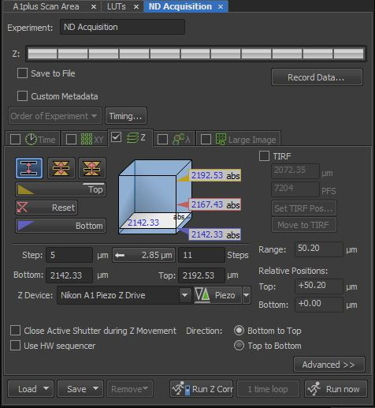

## **XY Image at Multiple Locations:**

1. Select the **ND Acquisition** window.
2. Select **XY**.
3. Select **“Include Z”** option to include the Z-position focus with each XY location.
4. Viewing the sample either by eye (ocular) or by scanning, move the specimen using the automated stage to the first location.
5. Focus on the specimen.
6. Select **Add**.
7. Again, viewing the sample either by eye (ocular) or by scanning, move the specimen using the automated stage to the next location. Focus on the specimen and select **Add**.
8. Repeat until all locations have been added.
9. For a single XY image at multiple locations, select **Run Now**.
10. To stop the scan early and **SAVE DATA**, select **Finish**.

To stop the scan early and discard the data, select Abort.

1. For XY-Location over time, also set **Time** parameters and select **Run Now**.
2. For XYZ-Location, also set the **Z** parameters and select **Run Now**.

*Note: Once multiple XY locations have been acquired, the locations can be stitched together into one large image by selecting* ***Image / ND Processing / Stitch Multiple Points to Large Image****.*

***A preferred method for acquiring a Large Area Scan is described in section “VI”.***

## **Large Area Scan at Multiple Locations**

1. Select the **ND Acquisition** window.
2. Select **XY**.
3. Viewing the sample either by eye (ocular) or by scanning, move the specimen using the automated stage to the first location.
4. Focus on the specimen.
5. Select **Add**.
6. Again, viewing the sample either by eye (ocular) or by scanning, move the specimen using the automated stage to the next location. Focus on the specimen and select **Add**.
7. Repeat until all locations have been added.
8. Select **Large Image.**
9. Set either a grid (e.g., 3x3) or size (e.g., 6.0mmx6.0mm) for each Large Image scan.
10. Select **Run Now**.
11. To stop the scan early and **SAVE DATA**, select **Finish**.

To stop the scan early and discard the data, select Abort.

1. For XY-Large Image over Time, also set **Time** parameters and select **Run Now**.
2. For XYZ-Large Image, set the **Z** parameters and then from the **Order of Experiment** select **Z series (Large Image).**
3. Select **Run Now**.

# **Large Area Scan**

Large Area scans may be performed within the Nikon A1 software by two different methods:

**Large Image** – preferred for a large area scan/montage of a single XY plane. This option will only save the final stitched XY Large Image. The file will be saved as an ND2 file. There is no option to save an XY image for each scan position, nor is there an option to generate a Z-series at each XY scan position.

**Acquire/Scan Large Image** – preferred when it is necessary to acquire an XYZ series for the large area scan/montage. An XYZ series at each XY position within the large area scan may be generated and saved and/or a Maximum Intensity Projection at each XY position within the large area scan may be generated and saved. In addition, the Scan Large Image option allows the user to Save data for each individual XY scan position and for the final stitched XY large image scan.

## **Large Image**

1. To scan an XY Large Image, select the Large Image icon from the Acquisition menu.

1. The following settings within the Scanning Wizard are suggested:

**Use HDR** – No, turn this option off. This is for a High Dynamic Range image.

**Use Z for Focus Surface** – Yes, select this option. This will allow you to mark the Z focus position at different XY locations so that structures remain in focus throughout the large image scan. At least 3 XY locations must be identified when using the **Shape** option to set your Large Image boundaries. The Z Focus Surface will not be activated if only two locations are selected.

**Capture Multichannel** – No, turn this option off. This option would allow the use different Experiment defaults for unusual color combinations.

**Filename** – Yes, designate the filename for the Large Image scan.

**Save File(s) Into Folder** – Yes, designate the drive/directory to which the image will be saved.

**Shape** – Allows the user to define the XY area boundaries over which the Large Image will be scanned. In addition, it allows the user to define the Z-focus position at multiple locations across the Large Image, so that structures remain in focus throughout the large image scan, employing the Z for Focus Surface option.

Recommended:

**Rectangle by 3 Corners**

**Rectangle by 4 Sides**

**Convex Envelope** – recommended for uneven and/or oddly shaped samples.

Mark at least the four corners and several XY locations within the middle of the sample.

**Define without Capturing** – No, turn this option off.

If this option is off (not selected), then the user may select the **Live** button to scan the confocal image and optimize the XY boundary and Z focus. Once optimized, click on the black arrow or the **Add** button to mark the boundary. A single scan will be captured to mark the boundary.

If this option is selected, then the user cannot access the **Live** button. XY boundaries must be identified through the **oculars** by selecting either the Eyepiece-EPI or Eyepiece-DIA tab.

Note: This option can be toggled on/off. If ocular view is needed to find an outer boundary, select the Define without Capturing option. Once the boundary has been found, then deselect the option and optimize the focus using the Live button.

For each boundary, once located and optimized, select the **Add** option or click on the black arrow to mark the boundary.

**Stitching via**

**Optimal Path** – Recommended

The software will identify and contour (cut) the stitch along areas where the overlapping regions are least different.

**Pixel intensity in the overlapped regions will be preserved when using the Optimal Path option.**

**Blending** – May be useful for some samples.

Areas of the image that are overlapping will be blended/averaged and may result in a blur in the image along the stitched seam.

**Pixel intensity in the overlapped regions will be altered/changed due to the blending (averaging) algorithm.**

**Precise Stitching (Image Registration)** – Yes, use this option.

Precise Stitching uses an Image Registration algorithm to identify the optimal stitch.

If this option is deselected (turned off), then the software will stitch the imaging using the defined % overlap and the Image Registration algorithm will not be used.

**Automatic Shading Correction** – No, turn this option off.

This option is designed to provide software correction for transmitted light (brightfield/DIC) images that do not have an even intensity across each field of view.

1. Once the image boundaries have been defined, select **Run** (green arrow) at the bottom of the Scanning Wizard to begin the Large Image scan. Once the scan has been completed, the software will automatically stitch the large area and save the single large area image as an .ND2 data file to the designated directory.

## **Scan Large Image**

1. To acquire the Large Area Scan, select **Acquire** / **Scan Large Image** from the top menu bar.
2. Under the **Capturing** section, confirm that the Optical Configuration = Current and the Objective is set to 25x.
3. Set the **Area** by selecting the **Number of Fields in the X and Y direction** or by setting the **Left, Top, Right, and Bottom Limits**.
4. **Left, Top, Right, and Bottom Limits** can be set either by scanning or by viewing by eye.

*To view by eye, switch to ocular viewing by pressing the “Bino” button on the front/left of the microscope itself.

*To set while scanning, select **Acquire** / **Scan Large** Image and then click on the green scan arrow at the bottom left of the Scan Large Image menu.

1. For many specimens, using a 1.5x-2.0x Zoom will generate a large scan that has a more even intensity distribution across the field of view.
2. Set the **Stitching** to **15% Overlap**, stitching **Via Blending or Optimal Path**, and checkbox **Image Registration** for Precise Stitching. See above descriptions for Blending/Optimal and Precise Stitching.
3. Set the **Shading Correction** to “Off (not available)”.
4. Set the **Save** option to either **Create Large Image, Store Single Images, or Create Both**.

The Large Image will be stored in the .nd2 file format.

Single Images may be stored in either the .tif, jp2, png, bmp, or jpg file formats.

1. A Z-series may also be collected at each position of the Large Area Scan. Select **Z-Series** to generate and save the individual Z-series and/or the Large Image Z-series. Alternatively, a Maximum Intensity Projection (MIP) may be created for each Z-series for each individual position and the Large Area Scan. Select **Max IP** to generate and save a Maximum Intensity Projection image.

*Note: Either the Z-Series or the MIP may be generated and saved, but not both.*

1. To set the Z-Series boundaries, use the **ND Acquisition Z-Series** menu **before** entering the **Acquire / Scan Large Image**. Set your **Bottom** and **Top** Z boundaries and Z **Step** within the ND Acquisition menu. Once your boundaries have been set, use the software to return your current focus position to the middle of the Z-stack. Make note of the **Step** and the number of images (**Steps**).
2. Once the Z-Series parameters are selected within the **ND Acquisition** window, select **Acquire / Scan Large Image**. On the right side of the window within the Z-Series box, enter the **Count** (# images per Z-series), the **Step** (Z step size), and the **Z-Drive** (TiZDrive).

The Scan Large Image will perform a Z-series around your current focal position. Enter the **Step** for the Z step size and then **Count** for the total number of images within the Z-series. For example, if you enter a 10um **Step** and 11 **Count**, then the software will collect 5 images below your current focal plane and 5 images above your current focal plane, imaging through a total Z-thickness of 100um.

1. Select **Scan** to begin collection of the Large Area Scan. A new window will appear with a montage of stitched images.

# **3Dimensional Image Display Options**

* + - 1. **Main View** = Single XY image through Z-series
      2. **Slices View** = Orthogonal (Cross-Sectional) View
      3. **Volume View** = MIP or Depth Shaded (Topographic)
      4. **Tiled View** = Matrix of all images in XYZ series
      5. **Maximum Intensity Projection** = MIP image
      6. **Minimum Intensity Projection**

The 3D Image Display icons are located at the top of an XYZ image series.

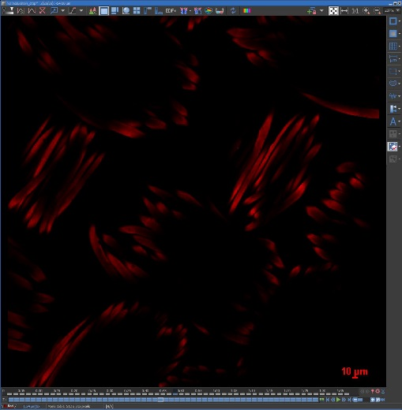

**Main View**

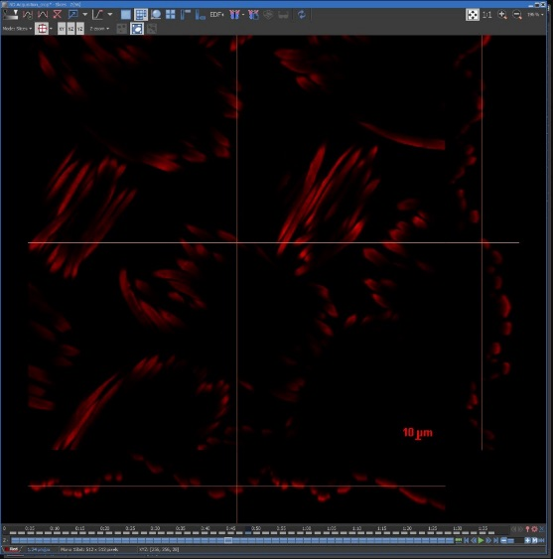

**Slices View**

Also called an Orthogonal or Cross-Sectional View

orthogonal

**Slices View Options**

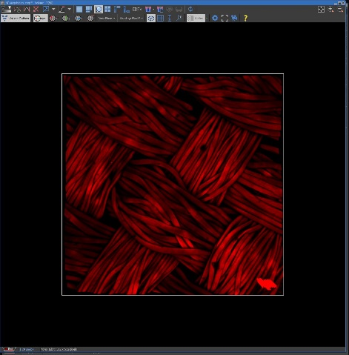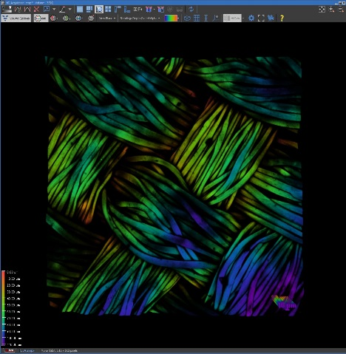

**Volume Views**

Max Intensity Projection

Depth Shaded View

**Volume Options**

**Image = Opacity**

0-100% Typically 100

**Edge Enhancement**

On/Off Typically OFF

**Maximum Intensity Projections**

Add MIP view for X, Y, or Z

Typically OFF

**Z-Zoom**

Expand Z thickness

Typically 100%

**Blending Mode**

Alpha

MIP

Depth Coded Alpha

Depth Coded MIP

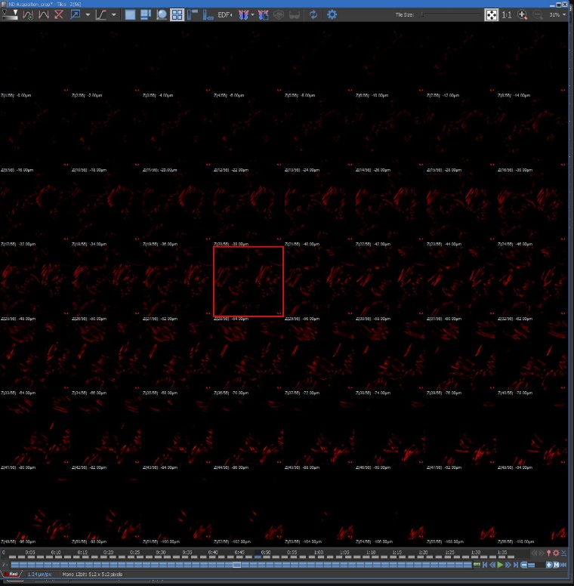

**Tiled View**

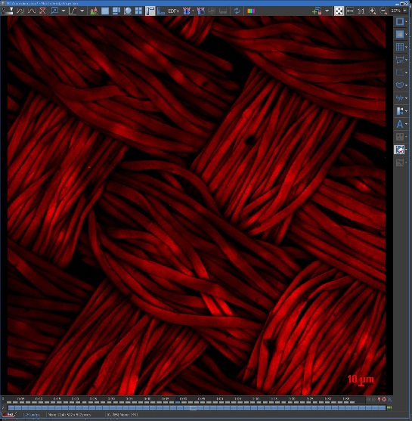

**Maximum Intensity Projection**

**3D Movie Maker in the Volume View.**

**Movie Maker Option**

1. Select the display orientation for your first image in the movie and click on the “**+**” sign.
2. Change the display to the second orientation in the movie and click on the “**+**” sign.

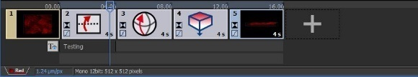

1. Select the green arrow to preview the movie or select the red X to delete the movie series.
2. Select the blue cog for the Movie Maker Settings options.
3. Select the film clip icon to generate the movie.
4. Select **File / Save As** to save the movie in an **AVI** format.

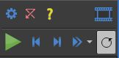

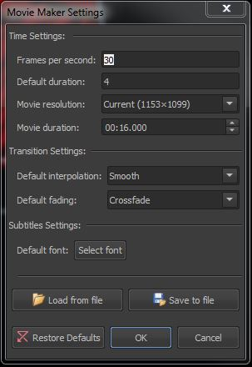 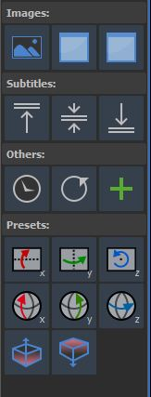

**Preset Options**

Drag and drop icon into the movie stream.