**Nikon-STORM System Instructions for MSU**

**June 2015**

**Caution!!**

**\*STORM/TIRF Lasers are very intense. Use caution when working with these lasers.**

**\*Never look down the barrel of the objective where the laser exits the objective lens.**

**\*Always wear Laser Safety Goggles during Laser Alignment.**

**\*Always use the TIRF stage which includes Laser Safety Interlocks.**

**Sample Set-up:**

1. Prepare sample in 35mm MatTek dishes that have a #1.5 glass coverslip bottom.
2. Prepare fresh STORM Imaging Buffer: 620ul Buffer B + 70ul MEA + 7ul Glox

Keep the Imaging Buffer on ice. The buffer will last approximately 1 hour.

1. Use about 350ul imaging buffer per 35mm dish.

**Instrument Set-up:**

1. Turn all components of the Nikon A1 hardware “ON”.
2. Attach the TIRF stage on top of the standard stage insert.
3. Select the 100x (NA 1.49) TIRF lens. Clean the objective well.
4. Remove DIC Prism from beneath objective lens (100X 1.49NA).
5. Open Elements with **“Andor with N-STORM”** drivers.

If you receive a “Driver Error”, be sure that the ANDOR camera is turned on. The “ON” button is a flat, silver button located at the middle, back of the camera.

1. It would be helpful to have the following Elements Windows open and available:

TiPad

N-STORM

DU-897 SettingsTIRF/SR-active Window

LUT

**Align TIRF:**

1. Select the **STORM** Optical Configuration from top toolbar.
2. Make sure the objective lens is close to the correct focus position and not “escaped.”
3. Make sure the correction collar is set to the marked position (sharpie mark).
4. Be sure the TIRF Stage coverplate is in place. A laser interlock will engage when the coverplate is removed, so the plate must be in place for the laser shutter to open.
5. Use **Ti Pad** window in Elements to set **TIRF angle** to **~3500**, or straight up to the ceiling.
6. Use **N-STORM** window to turn **647nm laser** up to 10%.

Note that the Laser Intensity is displayed in a log scale.

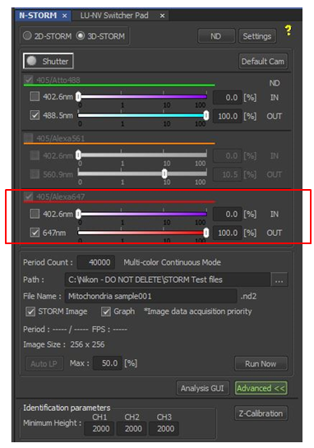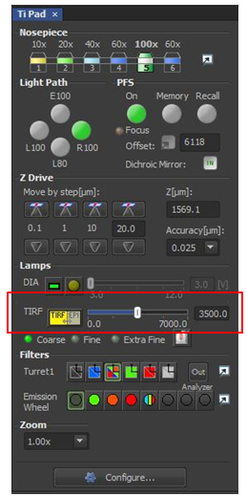

1. 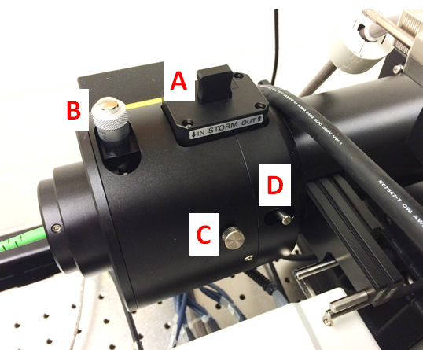Insert the STORM lens (**A**) (push down), and confirm that the ¼ waveplate is inserted.
2. Click on the Shutter icon at the top of the N-STORM menu to turn the laser on.
3. Adjust top knob on TIRF arm (**B**) to center laser above microscope, if necessary.

Remember to wear Laser Safety Googles!

1. Unlock set screw (**C**) and focus the beam with slider (**D**) until the beam is as tight as possible.
2. Use **Ti Pad** in Elements to move **TIRF angle** until the beam is walked down, near to the critical angle (approx. 4,000). The final angle will be fine-tuned before imaging begins.
3. Turn the laser “OFF” by clicking on the Shutter icon at the top of the N-STORM menu.

**Image Acquisition:**

1. Focus on the sample by eye (eg, EpiTxRed) or by using the Perfect Focus System (PFS).

For PFS, add a drop of oil to the 100x objective lens. Focus down (away) slightly (50-100um).

Place specimen on the stage and select PFS. The PFS button will blink until the coverslip focus is located.

Using Fine Focus, focus up until the PFS button stops blinking (constant green). The Fine Focus button will no longer control the Z-focus. At this point, use the PFS Focus knob to control the specimen focus.

1. Switch to **STORM** Optical Configuration.
2. Use **Ti Pad** to fine tune the TIRF angle in Live Mode until signal to noise is optimum.
   1. Use as little laser power as possible (<1%).
   2. Select “Play” icon to turn the laser and camera on for imaging. If you do not see an image, be sure that the microscope light path is set for the camera (R100). Increase laser power until a fluorescence image is detected.
   3. Select Camera ROI (located at the top of the camera image). The button will be green when selected.
   4. Click on the icon to the right of the “Extra Fine” option to control the TIRF angle by the mouse roller ball.

Remember that the TIRF angle may be adjusted in a Coarse (100), Fine (5) and Extra Fine (0.1) increments. Increase TIRF angle until the image is very bright. This is the correct position for STORM. A further increase in the TIRF angle will significantly reduce the image intensity. At this point you will be in TIRF mode. You can do TIRM-STORM, but typically data is acquired in a non-TIRF mode.

* 1. Once the TIRF angle is set, select “Stop” icon to turn the camera and laser off.

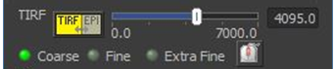

1. At the top of the **N-STORM** window, select **2D-STORM** or **3D-STORM**. Confirm that the astigmatic 3D STORM lens (located in front of the camera) is OUT (pulled towards you) for 2D-STORM and IN (pushed away from you) for 3D-STORM.

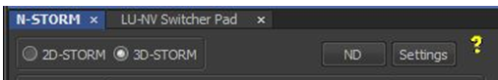

1. Click the **“Settings”** button to define whether the data will be a **Single-Color Continuous** experiment, a **Multi-Color Continuous** experiment (select the channels to be used), or a **PALM-type** experiment (**Normal** mode). For a PALM-type experiment, set the activation laser and # activation frames (typically 405nm laser and 1 activation frame) and the reporter laser and # reporter frames (typically 647nm laser and 10 reporter frames).

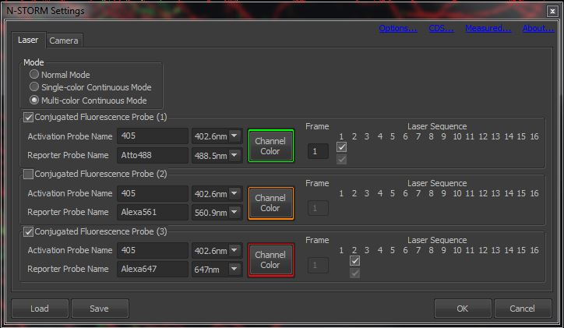

1. STORM can be done with up to 3 fluorophores, but generally only 1-2 dyes are used for d-STORM.
2. 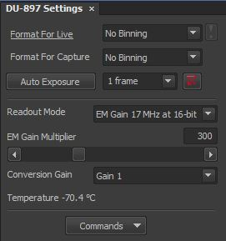In the **DU-897 Settings** window, select:

**No Binning**

**1 frame exposure time**

**EM Gain 17MHz at 16 bit**

**EM gain ~300**

These settings will be automatically loaded if you click the **“Default Cam”** button at the top right of the **N-STORM** window.

1. At the bottom of the **N-STORM** window, set the **Period Count** (typically 40,000), the **Directory** where your images will be saved and the **File Name** for your STORM data set, and select the check boxes next to **“STORM Image”** and **“Graph”**.

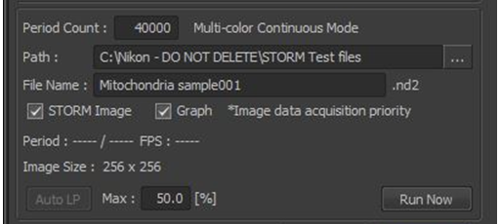

1. Make sure that the **Laser Power** for each laser that will be used is set to **100%**. Blinking will not occur if the laser is not set to 100% intensity. Also, remember to remove all ND filters. This setting will not show in the dialog box, so check the Laser Controller itself. To remove the ND filter, use the **TIRF/SR-active** window.

The **405nm laser** should beleft at **0%** unless you want to “pump” your fluorophores to increase blinking rate. To pump the fluorophore with 405nm, use only a small amount of **405**, e.g. **1%**.

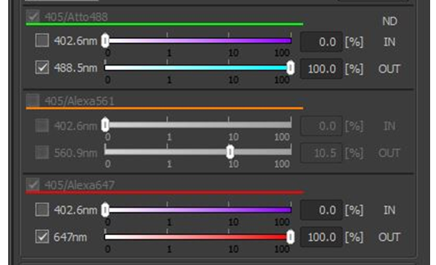

1. Click **Run Now**.
2. For 3D-STORM acquisition, a window will appear prompting you to focus on the coverslip, then on your sample. The software will automatically turn the camera on and set the laser intensity to 0%. Increase the laser intensity in order to see the fluorescence from the sample. Focus down and select **OK** to set the focus of the coverslip. Bring your sample back into focus and select **OK**.

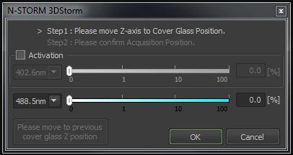

1. As the STORM data is acquired, three windows will be displayed.

Preview Image Window: showing the super resolution map of your sample being built in real time.

Once the Preview Image has filled in well (this is subjective), select **Finish** to end the experiment.

Graph of Molecule Counts per frame: if this number drops below **~10**, the intensity is becoming too low.

Select **Finish** to end the experiment.

ND Progress: indicates the amount of time that has elapsed. For bright images, typically 1-2 minutes may be sufficient.

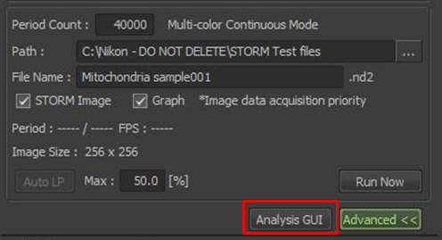

1. Once the acquisition is complete, click on **“Analysis GUI”** at the bottom right of the **N-STORM** window.

**Image Analysis:**

1. In the new analysis window that appears, open the file that you would like to analyze (**A**). The analysis window will automatically display the last image that was analyzed. So, be sure to select File/Open and load the correct data set.
2. At the bottom of the image, select an individual channel (Not the “all” tab) (**B**).
3. Scroll to a part of the time lapse (near the end) in which the spots are well-separated and background is low (**C**).
4. Visually select a single spot that is dim (but still clearly a “real” spot), well separated from the other spots, fairly round. Center the spot in the field of view and use the mouse roller ball to zoom in on the single spot.
5. Select the **“Peak Statistics”** tool from the toolbar at the right of the window (**D**).
6. A grid will now appear over your cursor. Center this grid over the spot and Double-Click. Nothing will appear to happen in the software, but the double-click will set the analysis parameters based on the single spot.
7. Repeat the Peak Statistics for each remaining color/channel.

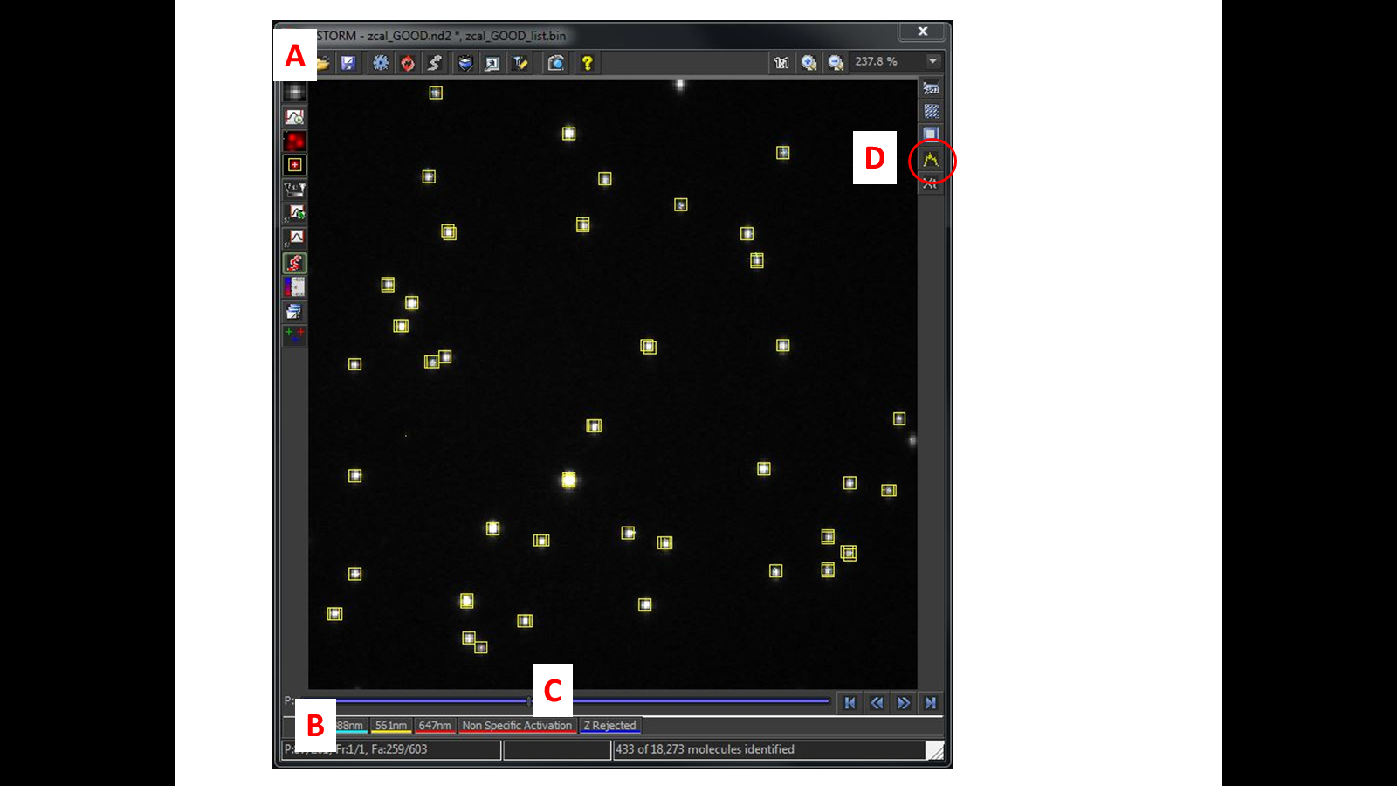

1. To test your analysis settings, select the **“Start STORM Analysis”** icon and select **Test**.

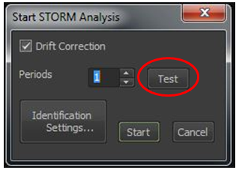



1. Positively identified spots in the STORM image will be identified with a yellow box. Make sure **Mark Points** is selected on left hand frame of image in order to view the yellow boxes.

If only a few yellow boxes (positive spots) are identified, you may need to manually modify your “Identification Settings” which define the acceptable spot intensity.

1. To manually modify your Identification Settings, click on the **Settings** icon near the top of the **Analysis Image Window**.
2. 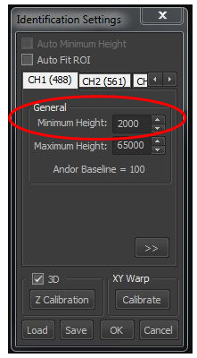In the **Identification Settings** window, a lower value for **“Minimum Height”** will allow the software to locate and define dimmer points as positive spots. A higher value will limit positive spots to only the brighter points. Each color/channel will have its own tab.

Make sure that **“Maximum Height”** is set to **65000**, which is the maximum brightness allowed by the camera. Extremely bright spots are likely just reflective dust, aggregates, etc. Lowering the Maximum Height value will allow the software to exclude the bright spots.

1. To re-test the analysis using the new Min/Max values, click on the **“Start STORM Analysis”** icon again and click the **“Test”** button.
2. Once you are satisfied with the analysis settings, click on the **“Start STORM Analysis”** icon again and select **“Start”** to process your images. 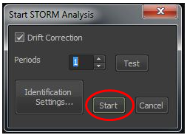
3. **Drift correction** is performed automatically, but can be removed by clicking on the **Drift correction** icon on left hand side of the image.
4. Click on the **Low Res Raw Image** icon on left hand side of the image and select No Background to hide the low resolution grey scale image.



1. For more precise control over point rejection, including **density filtering**,select the **Filtering Options** icon located at the top of the analysis image window.

I would recommend using the **ROI Tool** (located on the right side of the analysis image window). Select the **ROI Tool** icon and then draw a small ROI around a representative area within your image.

This will minimize the part of the image being processed while you test various Filter settings and BEFORE you attempt a final filtering process on the entire data set. This will speed up the process and reduce lag while you try different values for the density filter.

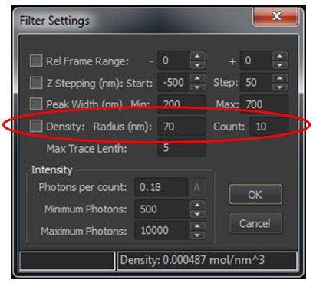The Density filter will limit the positive spots to only those spots that have a high density of neighboring spots. It will limit the positive spots to only those that have a certain number of neighboring spots (Count) within a certain area (Radius).

**Density Filter settings should be noted and reported in the Materials & Methods section of a publication. All comparison images should be analyzed with identical Density Filter settings.**

1. For 3D-STORM images, a 3D model of your data may be displayed by selecting the **3D** icon located at the top of the analysis image window. In addition, a display of the **Heigh Map** may be displayed by selecting the icon located on the left of the analysis image window.

**Instrument Clean-Up:**

1. Save all data and Exit out of the Elements software.
2. Remove specimen from the microscope stage and carefully clean the 100x oil objective.
3. Return the microscope to the 10x objective setting.
4. Remove the TIRF stage.
5. Remove the 3D STORM lens adjacent to the camera.
6. Remove the STORM lens located on the TIRF illuminator.
7. Shut down the Nikon A1 hardware.
8. Indicate “STORM” in the comment section of the log book.