Nikon A1Rsi Confocal System Instructions for MSU
January 2024

Caution!!
*The confocal lasers are very intense. Use caution when working with these lasers.
*Never look down the barrel of the objective where the laser exits the objective lens.

Instrument Set-up
- Turn all components of the Nikon A1 hardware “ON”.
- Open the Nikon A1 NIS Elements software using the Nikon A1 Confocal driver.
- The software will automatically open the following Nikon A1 acquisition windows:
A1Plus Pad
TiPad
A1Plus Scan Area
LUT
ND Acquisition
XYZ Navigation

Focus on Specimen
- The Nikon automated microscope is controlled through the TiPad widow.
- Through the TiPad window, select the objective for imaging and place specimen, coverslip down, on the stage.
- Select either the Eyepiece-EPI or Eyepiece-DIA tab for ocular viewing.
The red “Remove Interlock” will be displayed, indicating that the laser light is currently blocked and will not be viewed through the ocular.
- If viewing fluorescence (Eyepiece-EPI), select the Optical Configuration (OC) for ocular viewing:
DAPI Blue fluorescence
GFP Green fluorescence
TxRed Red fluorescence

Note: CFP and YFP fluorescence cubes are also available, but not currently installed on the microscope. Please let me know if you will need access to either cube for ocular viewing during your imaging session.

- When viewing fluorescence by eye, remember to open the XCite fluorescence light shutter and adjust the light intensity with the remote controller, located to the right of the microscope.
- For viewing Transmitted Light (Brightfield/DIC) by eye (Eyepiece-DIA), the shutter and light intensity are controlled through the Eyepiece-DIA window only.
- Once the area and focus has been selected, click on the Nikon A1 tab to return to confocal mode. Wait for the red “Remove Interlock” icon to turn from red to grey, indicating that the ocular port is now completely blocked, preventing laser light from being view by eye.

Optimize XY Image
- Select the correct Optical Configuration (OC) for fluorescence imaging. The OC’s are located on the top menu bar:
4CH : B-405(450/50), G-488(525/50), R-561(595/50), FR-647(700/75)
4CH-TD: B-405(450/50), G-488(525/50), R-561(595/50), FR-647(700/75) + TD channel
BOFR : C-445(510/50), O-514(595/50), FR-561(700/75) + TD channel
BOFR2 : C-445(510/50), O-514(580/40), FR-561(700/75) + TD channel
COFR : C-445(485/35), O-514(595/50), FR-561(700/75) + TD channel
CY : C-445(485/35), Y-514(545/40) + TD channel
CYR : C-445(485/35), Y-514(538/33), R-561(605/50) + TD channel
CYFR: C-445(485/35), Y-514(565/70), FR-561(660LP) + TD channel

Note: CYR and BOFR2 have very poor sensitivity for YFP emission due to the mirror design. CYFR, COFR and BOFR will exhibit the best YFP sensitivity.

- Select correct combination of PMT Detector Channels to be used for your specimen.
- Recommended Default Settings for Scan Parameters include:
Averaging: 1
Dwell Time: 2.4 usec/pixel
Channel Mode: Sequential
Scanning: Galvano
Pixel #: 1024x1024 pixels
Pinhole: 1.0 AU
Blue Gain: 100 Blue Laser: 5%, no ND
Green Gain: 20 Green Laser: 1%, no ND
Red Gain: 20 Red Laser: 1%, no ND
Far Red Gain: 100 Far Red Laser: 1%, no ND
TD Gain: 50
Note: In the Nikon A1 Software, image brightness will depend on the PMT Gain, Laser %,
and Dwell Time. For a brighter image:
*Increase PMT Gain setting.
This will affect the brightness of only the single detection channel. Gain settings will not affect photobleaching.
*Increase Laser %.
In sequential mode, this will affect the brightness of only the single detection channel and may increase photobleaching of the same detection channel.
*Longer Dwell Time
This will make all channels brighter, but may increase photobleaching.

- To Reuse scan parameters from a previous experiment:
Open the previous data set
Right click on the image
Select Reuse Camera Settings
- The image field of view may be optimized through the A1Plus Scan Area window.
For a full field of view, ensure that in the A1Plus Scan Area, Zoom = 1.
- Click Live and optimize the image.
- Click Capture to record the image.

Save Image:
- Data must be saved directly to a USB or a remote hard drive.
DO NOT SAVE ANY DATA directly to the Computer Hard Drive.
- To save raw data (always recommended!), select File / Save As and save the raw data in the *.nd2 raw data file format.
- To export each channel as a separate color tiff image and/or export the overlay image as a color tiff image, select File / Save/Export to TIFF Files.
  - Select “Current Document” and enter the Output Folder (where the images should be saved) and the Name (filename for the tiff images).
  - Select Standard TIFF format and Split to Multiple Files options.
  - Export to:
RGB Image for Each Channel in Channel Color. Scale to 8-bit and Burn Scale (to include scale).
All Channels Merged to RGB Overlay Image. Scale to 8-bit and Burn Scale (to include scale).
  - Select “Export” at the bottom of the menu to export the images.
- To save a snapshot of the current image display, select the “x” key from the keyboard. This will save exactly what you see, exactly how you see it, as a 24-bit color TIF image.
After pressing the “x” on the keyboard, select File / Save As and save the image in a *.tiff file format.

ND Acquisition Options
Time
Depth
Location
Large Image
Wavelength
or any combination of the these (e.g., XYZ series at different locations over time)

XY Image over Time
- Select the ND Acquisition window.
- Select Time.
- Select Phase 1.
- Enter Interval. Interval = time from the start of image 1 to the start of image 2
- Enter Duration or Loop (but not both).
Duration = total time for completion of Phase 1
Loop = number of times Phase 1 is repeated
- For a simple XY-T series, be sure that the additional ND Acquisition options (XY Location, Z Series, λ Series, and Large Image) are not selected.
- To see a graph of Intensity versus Time during the image acquisition, select the Perform Time Measurement option. In no ROI is selected, the average intensity for the entire image will be plotted over time.
- Select Run Now.
- To stop the scan early and SAVE DATA, select Finish.
To stop the scan early and discard the data, select Abort.
Note: Depending on the speed and resolution required, images may be collected in several modes:
Galvano Uni-Directional: 512x256, 2 frame/sec
Galvano Bi-Directional: 512x256, 4 frames/sec
Resonance Uni-Directional: 512x256, 30 frames/sec
Resonance Bi-Directional: 512x256, 60 frames/sec

XY Image through Z-Depth
- Select the ND Acquisition window.
- Select Z.
- Select the first icon on the left to Define By Top Bottom.
- Confirm that Z Device is set to TI ZDrive.
- Begin scanning and set Top and Bottom boundaries of the Z-depth range.
Set Bottom boundary by turning the focus knob away from you and locating the lower boundary. Click Bottom.
Set Top boundary by turning the focus knob towards you and locating the upper boundary. Click Top.
Note: Top and Bottom boundaries may also be located by using the up/down arrow buttons in the XYZ Navigation window.

Note: Top = highest objective focus position
Bottom = lowest objective focus position

- Enter Step Interval or number of Steps.
To set the Z-step interval to Nyquist, click on the number (Suggested Step Size) that is displayed between the Step and # of Steps options.
- The Z Device option should be set to Ti ZDrive.
- Select Run Now.
- To stop the scan early and SAVE DATA, select Finish.
To stop the scan early and discard the data, select Abort.
To crop in XY:
Select Image / Crop.
Optimize the size and location of the red box on the image.
To crop in Z:
At the bottom of the XYZ series, press the Shift key, left click the mouse and drag to the right in order to select the desired range of images.
The selected buttons will turn from a blue color to a green color.
Right click on the selected buttons to “Keep Selected Frames” or “Delete Selected Frames”.
Note: A Piezo Z-Stage is available for fast XYZ imaging speeds. The piezo Z-drive is limited to a 100um Z-depth range and is typically used when performing very fast XYZ-time series, where the Z-movement becomes a rate-limiting factor. For high-resolution XYZ series, in which the time per image is several seconds or longer, use of the piezo Z-stage will not significantly improve the time resolution. Example:
128x128 pixel image, 50um thickness: piezo-Z stage 3 seconds, standard-Z 7 seconds, 2.3 x faster
512x512 pixel image, 50um thickness: piezo-Z 12 seconds, standard-Z 14 seconds, only 1.2 x faster

CAUTION: The Piezo Z-Stage can be easily damaged by pressing on the piezo stage itself.
Always turn Piezo Z-Stage OFF before adding or removing your specimen from the microscope stage!!

To use the Piezo Z-Stage:
- Install the Piezo stage plate on the microscope.
- Place sample on stage and focus on the specimen.
- Turn Piezo Z-drive controller “On”.
- Right click on the desk top and select Acquisition Controls/ XYZ Navigation. This will display the actual position of the Piezo drive: Z2 – Nikon A1 Piezo Z Drive.
- In the ND Acquisition software, set the Z Device to: Nikon A1 Piezo Z Drive.
- Focus to set the lower limit (Bottom) and the upper limit (Top).
- Click on the “Piezo” icon, “Keeps Z position & centers Piezo Z”, to set the center Z position of the Piezo to the center position of the specimen.
- Select Run Now to begin Z-series.

Reminder: Always turn Piezo Z-Stage OFF before removing your specimen from the microscope stage!!

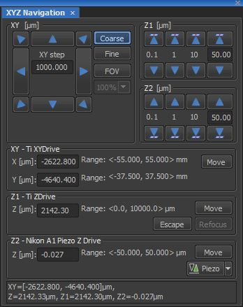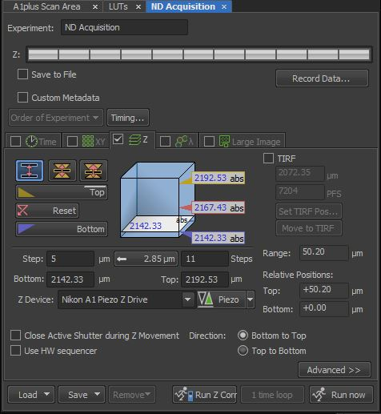

XY Image at Multiple Locations:
- Select the ND Acquisition window.
- Select XY.
- Select “Include Z” option to include the Z-position focus with each XY location.
- Viewing the sample either by eye (ocular) or by scanning, move the specimen using the automated stage to the first location.
- Focus on the specimen.
- Select Add.
- Again, viewing the sample either by eye (ocular) or by scanning, move the specimen using the automated stage to the next location. Focus on the specimen and select Add.
- Repeat until all locations have been added.
- For a single XY image at multiple locations, select Run Now.
- To stop the scan early and SAVE DATA, select Finish.
To stop the scan early and discard the data, select Abort.
- For XY-Location over time, also set Time parameters and select Run Now.
- For XYZ-Location, also set the Z parameters and select Run Now.
- To define XY-Locations by Well Plate parameters or for Random locations, select the Custom option located at the bottom right of the XY-ND Acquisition window.
Note: Once multiple XY locations have been acquired, the locations can be stitched together into one large image by selecting Image / ND Processing / Stitch Multiple Points to Large Image.
A preferred method for acquiring a Large Area Scan is described in section “VI”.

Large Area Scan at Multiple Locations
- Select the ND Acquisition window.
- Select XY.
- Viewing the sample either by eye (ocular) or by scanning, move the specimen using the automated stage to the first location.
- Focus on the specimen.
- Select Add.
- Again, viewing the sample either by eye (ocular) or by scanning, move the specimen using the automated stage to the next location. Focus on the specimen and select Add.
- Repeat until all locations have been added.
- Select Large Image.
- Set either a grid (e.g., 3x3) or size (e.g., 6.0mmx6.0mm) for each Large Image scan.
- Select Run Now.
- To stop the scan early and SAVE DATA, select Finish.
To stop the scan early and discard the data, select Abort.
- For XY-Large Image over Time, also set Time parameters and select Run Now.
- For XYZ-Large Image, set the Z parameters and then from the Order of Experiment select Z series (Large Image).
- Select Run Now.

XY Image using a combination of different Optical Configurations
- Select the first Optical Configuration to be used and optimize the parameters for the current sample.
- Right click on the Optical Configuration name, select Duplicate, and enter a new name (e.g., A14CH-Melinda).
- Select the next Optical Configuration to be used and optimize the parameters for the current sample.
- Right click on the Optical Configuration name, select Duplicate, and enter a new name for this Optical Configuration (e.g., A1CY-Melinda)
- Repeat for each Optical Configuration to be used.
- Select the ND Acquisition window.
- Select λ.
- Under Set-Up / Opt.Conf., enter each modified Optical Configuration to be used (e.g., A14CH-Melinda in line #1, A1CY-Melinda in line #2).
- Select Run Now to acquire a single image that combines each entered Optical Configuration.

Note: The exact parameters for each OC will be used, including specified lasers, dichroics, emission filters, PMT settings, Zoom, pixel density, etc. Be sure that all parameters are carefully selected in steps 1 and 2. If new parameters are selected (e.g., new PMT setting or Zoom), then be sure to right click on the modified OC and select Assign Current Camera Setting.

Large Area Scan
Large Area scans may be performed within the Nikon A1 software by two different methods:
Large Image – preferred for a large area scan/montage of a single XY plane. This option will only save the final stitched XY Large Image. The file will be saved as an ND2 file. There is no option to save an XY image for each scan position, nor is there an option to generate a Z-series at each XY scan position.
Acquire/Scan Large Image – preferred when it is necessary to acquire an XYZ series for the large area scan/montage. An XYZ series at each XY position within the large area scan may be generated and saved and/or a Maximum Intensity Projection at each XY position within the large area scan may be generated and saved. In addition, the Scan Large Image option allows the user to Save data for each individual XY scan position and for the final stitched XY large image scan.

Large Image
- To scan an XY Large Image, select the Large Image icon from the Acquisition menu.

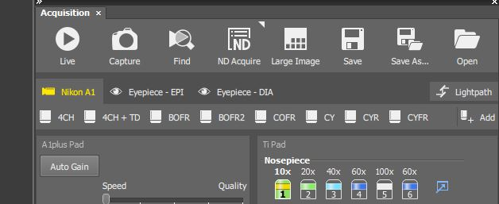

- The following settings within the Scanning Wizard are suggested:

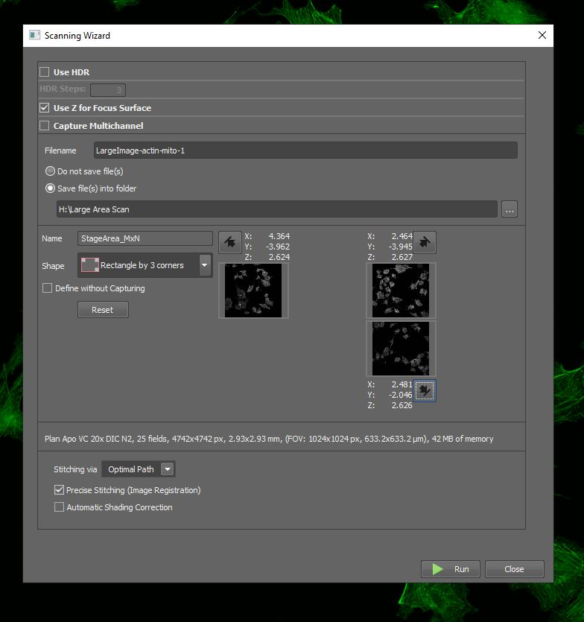

Use HDR – No, turn this option off. This is for a High Dynamic Range image.

Use Z for Focus Surface – Yes, select this option. This will allow you to mark the Z focus position at different XY locations so that structures remain in focus throughout the large image scan. At least 3 XY locations must be identified when using the Shape option to set your Large Image boundaries. The Z Focus Surface will not be activated if only two locations are selected.
Note: The PFS option does not function (automatically turns off) in the Large Image option.

Capture Multichannel – No, turn this option off. This option would allow the use different OC’s for unusual color combinations.

Filename – Yes, designate the filename for the Large Image scan.
Save File(s) Into Folder – Yes, designate the drive/directory to which the image will be saved.

Shape – Allows the user to define the XY area boundaries over which the Large Image will be scanned. In addition, it allows the user to define the Z-focus position at multiple locations across the Large Image, so that structures remain in focus throughout the large image scan, employing the Z for Focus Surface option.
Recommended:
Rectangle by 3 Corners
Rectangle by 4 Sides
Convex Envelope – recommended for uneven and/or oddly shaped samples.
Mark at least the four corners and several XY locations within the middle of the sample.

Define without Capturing – No, turn this option off.
If this option is off (not selected), then the user may select the Live button to scan the confocal image and optimize the XY boundary and Z focus. Once optimized, click on the black arrow or the Add button to mark the boundary. A single scan will be captured to mark the boundary.

If this option is selected, then the user cannot access the Live button. XY boundaries must be identified through the oculars by selecting either the Eyepiece-EPI or Eyepiece-DIA tab.

Note: This option can be toggled on/off. If ocular view is needed to find an outer boundary, select the Define without Capturing option. Once the boundary has been found, then deselect the option and optimize the focus using the Live button.

For each boundary, once located and optimized, select the Add option or click on the black arrow to mark the boundary.

Stitching via
Optimal Path – Recommended
The software will identify and contour (cut) the stitch along areas where the overlapping regions are least different.
Pixel intensity in the overlapped regions will be preserved when using the Optimal Path option.

Blending – May be useful for some samples.
Areas of the image that are overlapping will be blended/averaged and may result in a blur in the image along the stitched seam.
Pixel intensity in the overlapped regions will be altered/changed due to the blending (averaging) algorithm.

Precise Stitching (Image Registration) – Yes, use this option.
Precise Stitching uses an Image Registration algorithm to identify the optimal stitch.
If this option is deselected (turned off), then the software will stitch the imaging using the defined % overlap and the Image Registration algorithm will not be used.

Automatic Shading Correction – No, turn this option off.
This option is designed to provide software correction for transmitted light (brightfield/DIC) images that do not have an even intensity across each field of view.

- Once the image boundaries have been defined, select Run (green arrow) at the bottom of the Scanning Wizard to begin the Large Image scan. Once the scan has been completed, the software will automatically stitch the large area and save the single large area image as an .ND2 data file to the designated directory.

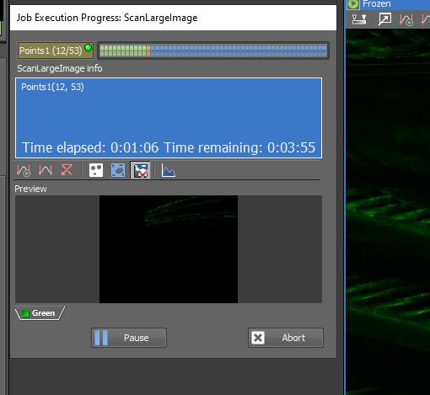

Scan Large Image

- For many samples, the Nikon PFS (Perfect Focus System) will help keep the specimen in focus across the entire Large Area Scan. To select the PFS, turn the PFS option “ON” either through the TiPad window or from the front of the Ti inverted microscope.
- Select Eye Port and focus on the sample using the PFS Remote Focus Knob.
- Select Eye Port to return to the confocal and optimize the scan parameters for your sample.

Note: The PFS works by using a long wavelength laser to reflect off the surface of the coverslip. This reflection requires a difference in refractive index between the sample and the objective immersion media. PFS cannot be used when imaging a fixed sample mounted in a glycerol-based mounting media with a 40x or 60x oil objective.

- To acquire the Large Area Scan, select Acquire / Scan Large Image from the top menu bar.
- Under the Capturing section, confirm that the Optical Configuration = Current and the Objective is set to the correct magnification.
- Set the Area by selecting the Number of Fields in the X and Y direction or by setting the Left, Top, Right, and Bottom Limits.
- Left, Top, Right, and Bottom Limits can be set either by scanning or by viewing by eye.
*To view by eye, switch to ocular viewing by pressing the “Eye” button on the front/left of the microscope itself.
*To set while scanning, select Acquire / Scan Large Image and then click on the scan arrow at the bottom left of the Scan Large Image menu.
- For many specimens, using a 1.5x-2.0x Zoom will generate a large scan that has a more even intensity distribution across the field of view.
- Set the Stitching to 15% Overlap, stitching Via Blending or Optimal Path, and checkbox Image Registration for Precise Stitching. See above descriptions for Blending/Optimal and Precise Stitching.
- Set the Shading Correction to “Off (not available)”.
- Set the Save option to either Create Large Image, Store Single Images, or Create Both.
The Large Image may be stored in either the .nd2 or .tif file formats.
Single Images may only be stored in the .tif file format.
- A Z-series may also be collected at each position of the Large Area Scan. Select Z-Series to generate and save the individual Z-series and/or the Large Image Z-series. Alternatively, a Maximum Intensity Projection (MIP) may be created for each Z-series for each individual position and the Large Area Scan. Select Max IP to generate and save a Maximum Intensity Projection image.
Note: Either the Z-Series or the MIP may be generated and saved, but not both.
- To set the Z-Series boundaries, use the ND Acquisition Z-Series menu before entering the Acquire / Scan Large Image. Set your Bottom and Top Z boundaries and Z Step within the ND Acquisition menu. Once your boundaries have been set, use the software to return your current focus position to the middle of the Z-stack. Make note of the Step and the number of images (Steps).
- Once the Z-Series parameters are selected within the ND Acquisition window, select Acquire / Scan Large Image. On the right side of the window within the Z-Series box, enter the Count (# images per Z-series), the Step (Z step size), and the Z-Drive (TiZDrive).

The Scan Large Image will perform a Z-series around your current focal position. Enter the Step for the Z step size and then Count for the total number of images within the Z-series. For example, if you enter a 10um Step and 11 Count, then the software will collect 5 images below your current focal plane and 5 images above your current focal plane, imaging through a total Z-thickness of 100um.
- Select Scan to begin collection of the Large Area Scan. A new window will appear with a montage of stitched images.

Spectral Imaging (XY-λ)
Set Optics:
- Open the optics Configuration box and select SD for Spectral Detection.
- Set the SD parameters. Recommended settings include:
Resolution (wavelength range per image): 6.0 microns
Channels: 32
Binning: 1
Lasers: Checkbox “on” each laser to be used for excitation during the lambda scan.
1st Dichroic Mirror: Be sure to select an excitation DM that matches the laser selection.
Start and End: Set the spectral wavelength range to be covered during the lambda scan.

Optimize Image:
- Focus on the specimen by eye (ocular) or by scanning using a standard filter configuration.
- Select Scan and optimize the scan parameters.
- The brightness of the images will be optimized by the single HV (high voltage) setting. If using multiple lasers, fine adjustments to image brightness may be made by adjusting each laser intensity individually.

Note: For accurate spectral unmixing, there should be no pixel saturation in the image.
The LUT display will show graphs for the average intensity versus wavelength and the
peak intensity versus wavelength. Optimize the HV so that the peak intensity is near the top of the curve but not saturated.

- Once the HV is optimized, if the overall image display is too dim, use the AutoScale to brighten the image display.
- If the image is grainy, increase the Scan Average to improve the Signal/Noise.
- Select Capture to create a final XY-λ dataset.
- If reference slides are available, Capture and Save an XY-λ dataset from each reference slide using identical configuration settings as those used above for the original specimen.

Define Reference Spectra:
- For Linear Unmixing of the overlapping emission spectra, a reference spectrum must be defined for each dye and/or autofluorescence signal within in the specimen. Optimally, it would be best to have a separate reference slide for each fluorescence signal detected within the original specimen. Alternatively, reference spectra can be define from the original specimen as long as regions containing a single fluorochrome and/or autofluorescence can be identified within the original specimen.
- To define each reference spectra, right click on the desktop and select Visualize / Spectral Profile.
- From the Spectral Profile menu, select ROI / Define.
- Define an ROI for each representative fluorescence signal (preferably from the stored images of the individual reference slides). Once the ROI has been drawn, select Finish.
- From the Spectral Profile menu, select the ROI to view the spectra.
- Select Store to save each reference spectrum.
Note: Although the software can display multiple ROI’s at one time (showing the spectral overlap), the software will only store one spectrum at a time.

Linear Unmixing:
- Once each reference spectrum has been stored, select Image / Spectral Unmixing from the top menu bar.
- From Category, select the defined ROI or the stored User-Defined spectral curve for each reference spectrum and click Add.
- The spectrum for each defined ROI will be displayed under Search.
- Select Unmix from the bottom, right corner of the window.
- A new multi-color XY image will appear, with each channel representing the separated fluorescence signals. The fluorescence intensity within the unmixed images are quantitative.
- Select Remainder Channel to include a separate image for fluorescent signals that cannot be assigned to one of the reference spectra during the linear unmixing.
- Once the reference profiles have been defined, select Image / Live Unmix for real-time linear unmixing of the overlapping fluorescent signals. To turn the Live Unmixing off, select the same option once again.

3Dimensional Image Display Options
      - Main View = Single XY image through Z-series
      - Slices View = Orthogonal (Cross-Sectional) View
      - Volume View = MIP or Depth Shaded (Topographic)
      - Tiled View = Matrix of all images in XYZ series
      - Maximum Intensity Projection = MIP image

The 3D Image Display icons are located at the top of the XYZ image series.
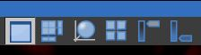

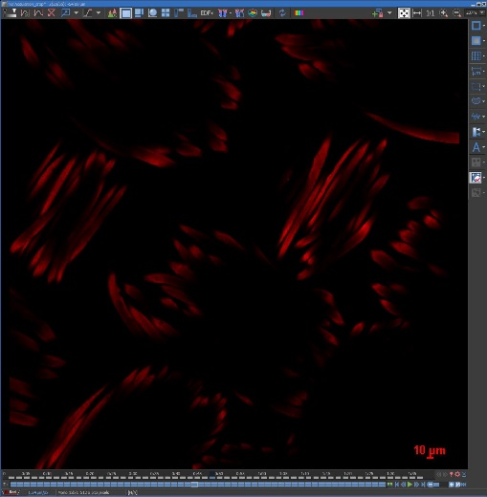
Main View

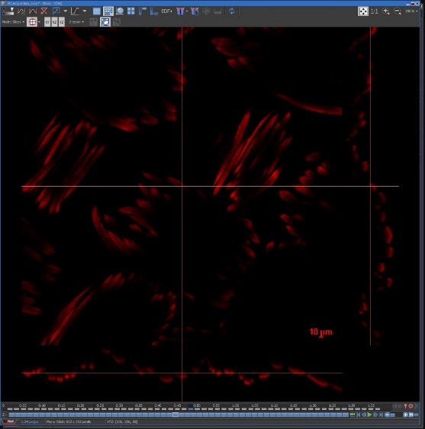
Slices View
Also called an Orthogonal or Cross-Sectional View

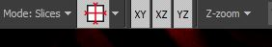
Slices View Options

Volume Views
Max Intensity Projection
Depth Shaded View
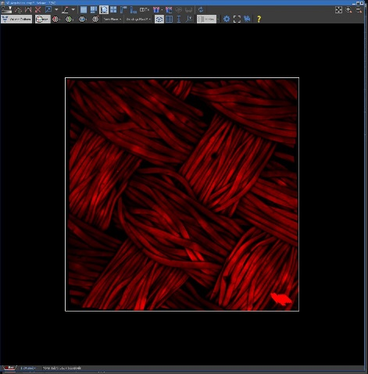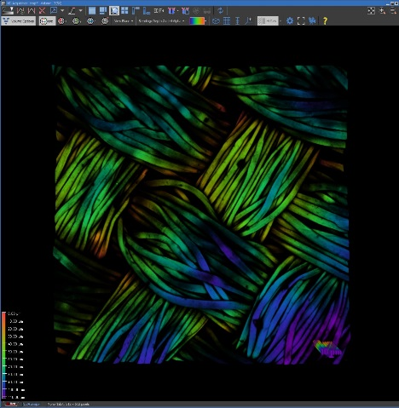

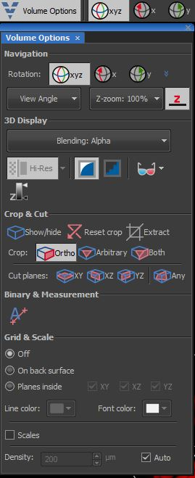
Volume Options
Rotation Angle
XYZ
X-only
Y-only
Viewing Angle
XY
XZ
YZ
Z-Zoom
Expand Z thickness
Blending Mode
Alpha
MIP
Depth Coded Alpha
Depth Coded MIP

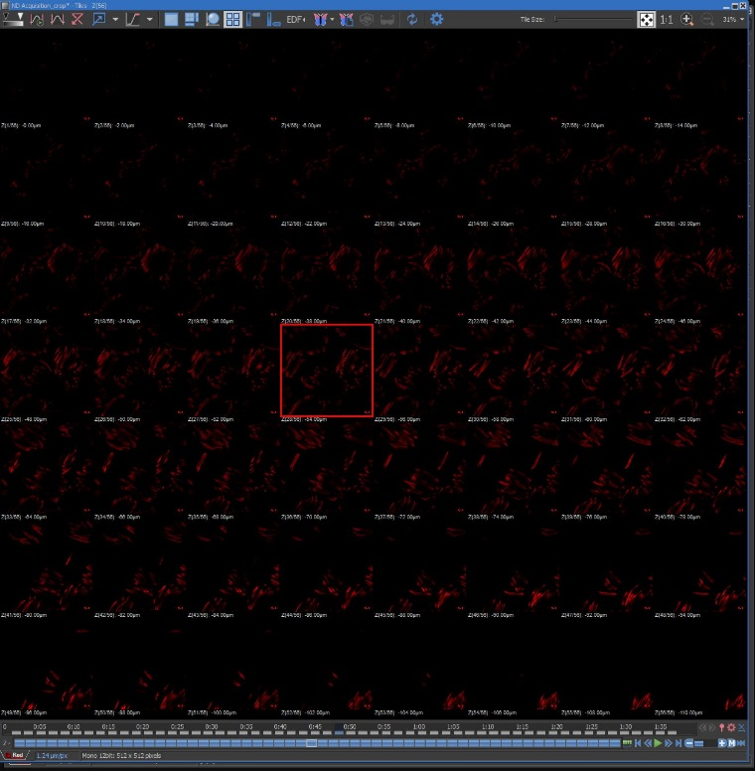
Tiled View

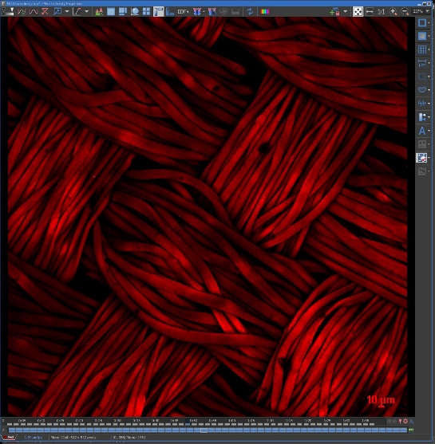
Maximum Intensity Projection

3D Movie Maker in the Volume View.

Movie Maker Option

- Select the display orientation for your first image in the movie and click on the “+” sign.
- Change the display to the second orientation in the movie and click on the “+” sign.
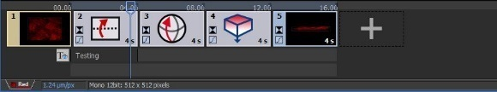

- Select the green arrow to preview the movie or select the red X to delete the movie series.
- Select the blue cog for the Movie Maker Settings options.
- Select the film clip icon to generate the movie.
- Select File / Save As to save the movie in an AVI format.

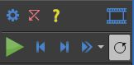

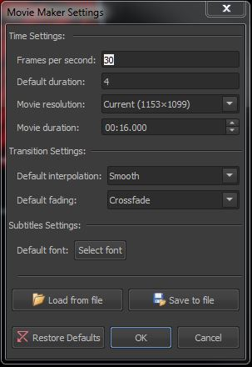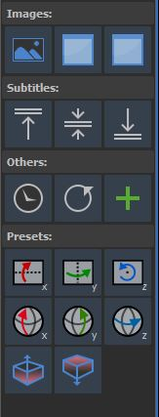
Preset Options
Drag and drop icon into the movie stream.
Updated 1/5/24

