Leica Stellaris 5 Confocal System Instructions for MSU
February 2024

Caution!!
*The confocal lasers are very intense. Use caution when working with these lasers.
*Never look down the barrel of the objective where the laser exits the objective lens.

Log into the Leica LASX Software
- Turn the components of the Leica Stellaris hardware “ON”.
- Log into the Windows software. The password is leica.
- Double click on the Leica LASX icon to open the software. Accept the default configuration and wait for the software to initialize.

Open a New Project
- Go to the Open projects tab and open a New Project. Right click on the project filename to Rename the project. Right click and select Save As to save the project in the .lif (Leica Image File) format to your USB drive. It is strongly recommended that a USB 3.0 drive (blue tip) or remote hard drive is used for faster saving. Connect the USB 3.0 drive to the USB 3.0 port (blue tip) located on the cord by the monitor.

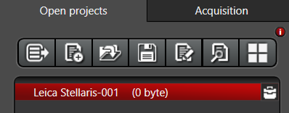

- From the Project settings tab, located at the bottom of the Open projects window, enter the filename for the first sample under the User defined image name option.

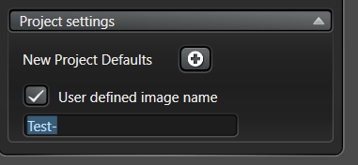

Note: Do not use symbols (such as +) in the filename. This will cause the Leica software to freeze/lock up.

Note: Do not use the New Project Defaults. Do not turn on the AutoSave option located under the New Project Defaults.

Note: In the AutoSave option, both an .xlef and .lof format will be generated. The .xlef file is the experiment directory that points to the .lof file which contains the image data. Both files are required to open your data. The Leica software will open the .xlef file, but not the .lof. However, the .lof file is required and must be located in the same directory as the .xlef since the .lof contains the image data.

Open and Set the Panel Configuration
To configure the six knob Control Panel located near the keyboard, click on the Show Panel Box Settings icon. Each knob of the Control Panel may be assigned a specific user-defined function. User-defined configurations for the Control Panel may be Saved and Opened on the lower right.
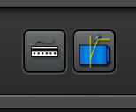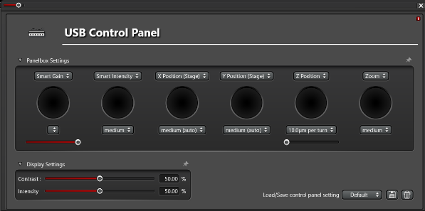

Set the Dye Configuration
- Enter the name of your dye in the Search Box and then drag the selected dye name into the grid area of Setting 1 box. The system will prompt “Switch laser on now”. Select OK.
- To add a second dye, click on the + button for a second Setting box and repeat step 1.
Note: Add all dyes to the configuration before proceeding to Step 3.

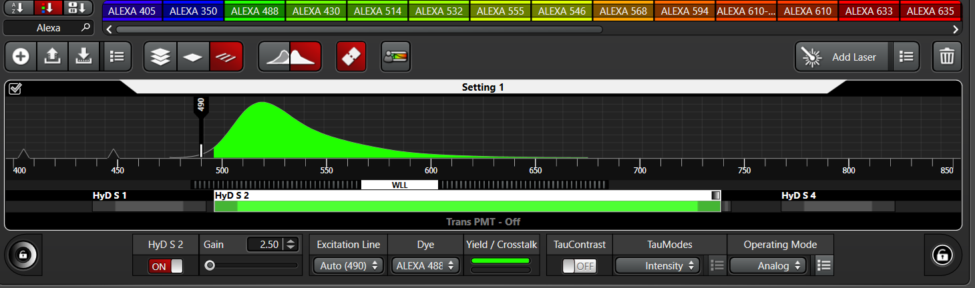

- Double click on the indicated laser line within each Setting box to set the Laser Line wavelength and Laser Intensity for each dye. Recommended Laser Intensity is 10%. Available laser lines include:
405nm diode laser
448nm diode laser
485-685nm White Light Laser (Supercontinuum), available in 1nm increments
- Double click on the colored portion of the detector bar (HyD S 2 for example) to set the emission range.
Begin wavelength should be at least 10nm higher than the selected laser line wavelength.
End wavelength should be at least 10nm lower than the adjacent higher laser line wavelength.
- Click on the colored outer ring of the lock symbol to select the color display for each channel.

Focus on Specimen
- The Leica automated microscope is controlled through a touchscreen widow located on the front of the microscope.
- From the touchscreen window, select the objective icon and then select the objective magnification for imaging. The selected objective will be shown in red. It is recommended that you begin with the 10x objective and increase magnification once the sample focus has been initially found.
Available Objectives:
10x HC PL APO CS2 dry objective, NA 0.40, WD 2.56mm
20x HC PL APO CS2 dry objective, NA 0.75, WD 0.62mm
40x HC PL APO CS2 oil objective, NA 1.30, WD 0.24mm
63x HC PL APO CS2 oil objective, NA 1.40, WD 0.14um
100x HC PL APO CS2 oil objective, NA 1.40, WD 0.13um
Note: A 20x HC PL APO CS2 multi-immersion (water, oil, glycerol) objective, NA 0.75, WD 0.66mm, and a 40x HC PL APO CS2 water-immersion objective, NA 1.1, WD 620um, are available for use but they are not installed on the microscope. See Melinda for access to these objectives.
- Place the specimen, coverslip down, on the stage. The automated stage is controlled through the handset located to the right of the microscope. The top wheel moves the stage forward/backward, while the bottom wheel moves the stage left/right. Buttons on the handset, to the left of the wheels, control either course (XY Fast) or fine (XY Precise) stage movement.
- From the touchscreen window, select the filter wheel icon for ocular viewing of either the conventional fluorescence or conventional transmitted light.
For conventional fluorescence, select the Incident FLUO button and then select the desired fluorescence color. Click the IL-Shutter button to open (yellow) the shutter or to close (grey) the shutter. From the microscope icon on the touch screen window, the intensity of the fluorescence lamp can be controlled by adjusting the FIM option (10%-100%).
LED_405 Blue fluorescence
GFP Green fluorescence
Rhod_LP Red fluorescence
For conventional transmitted light, select the Transmitted BF, DIC, or POL button. Click the TL-Shutter to turn on (yellow) or to turn off (grey) the halogen lamp. From the microscope icon on the touch screen window, the intensity of the halogen lamp can be controlled by adjusting the Intensity option (0-255), and the condenser aperture diameter can be controlled by adjusting the Aperture (1-24). The DIC prism adjustment is located within the filter wheel icon.
BF Brightfield
DIC Differential Interference Contrast
POL Polarized Light

- Once the area and focus has been optimized, select Live or Fast Live from the software to begin confocal imaging with the laser. To return to ocular viewing, select either FLUO for fluorescence or BF, DIC, or POL for transmitted light from the microscope touchscreen window.

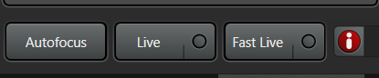

Optimize XY Image:
- Go to the Acquisition tab to set the acquisition parameters.
Recommended settings:
Format: 1024
Speed: 400
Bidirectional: OFF
Zoom Factor: 1.0x
Zoom In: OFF
Image Size: Current Field of View (FOV)
Pixel Size: Current size of each pixel in microns
Optical Section: Optical thickness/resolution in Z = d_{z}
Pixel Dwell Time: Time the laser spends per pixel
Frame Rate: Number of images per second
Line Average: 1
Frame Average: 1
Line Accu: 1
Frame Accu: 1
Rotation: 0
Pinhole: Defaults to 1AU

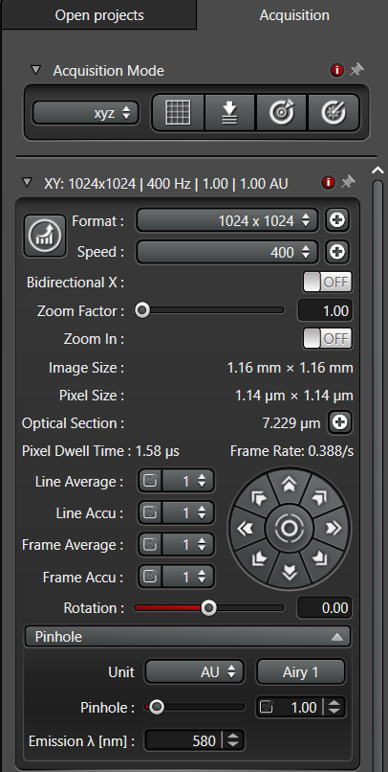
- Select Live or Fast Live to begin imaging and optimize the image intensity and quality.
From the Control Panel Box:
  - Adjust the detector Smart Gain, from 2.5 – 500. A value <250 is reasonable.
  - Adjust the laser Smart Intensity. A laser intensity value of 10% is reasonable.
  - Adjust the Z Position (focus) to optimize the focal plane. Locate the focal plane the provide the brightest and sharpest image and then optimize the Gain/Intensity.
  - Adjust the Zoom magnification, from 0.75-48x. A value of 1-3x is reasonable.

Note: The 6-knob Control Panel may be used to control the Gain and Laser Intensity of only one channel (color) at a time. In the Live imaging mode, click on the specific image (blue, green, or red) to be modified before adjusting the Control Panel options. There will be a thin white box around the selected image. In the Fast Live imaging mode, select the specific channel to be modified by clicking on the Setting box before selecting the Fast Live option. The selected channel will display the Setting tab in white.

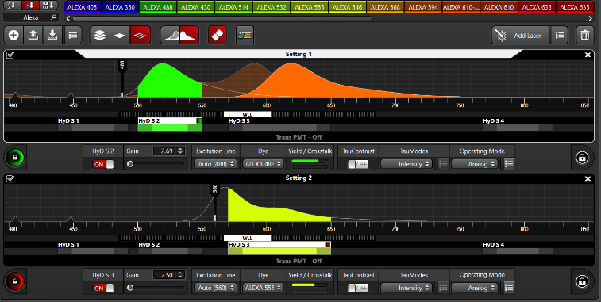

Image Display Modes
- The format of the image display may be adjusted using the icons to the upper right corner of the image. Options include:
  - Toggle from split screen display to a single overlay image.
  - Toggle Channel 1 (blue) display on/off.
  - Toggle Channel 2 (green) display on/off.
  - Toggle Channel 3 (red) display on/off.
  - Toggle the overlay display on/off.

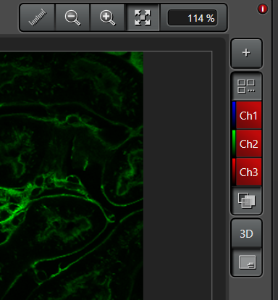

- The LUT (Look Up Table), which controls the color display for each channel, may be adjusted using the icons to the upper left corner of the image. Options include:
  - Toggle between Color display of the image, Over/Under Exposure display (orange display with blue representing saturation), and Greyscale display.
  - Auto rescale of LUT.
  - Reset (Auto rescale OFF).
  - Histogram display of the LUT.

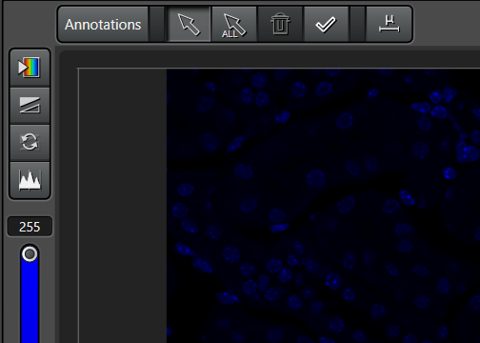
Note: Image acquisition and the associated LUT is automatically set to an 8-bit display (0-255 intensity levels). For 12-bit (0-4095) or 16-bit (0-65,535) acquisition and display, select Configuration, Hardware, Bit Depth = 12 bit or 16 bit.
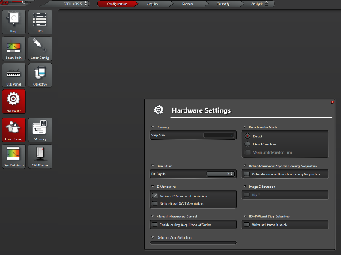

Capture and Save the Image
Once the image has been optimized, select Capture image to take a snapshot of the current image or select Start to begin collection of an image series (such as XYZ). The image or image series will be automatically saved to the Open project with the User defined image name.
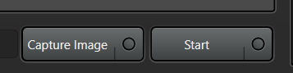

Export Images to a TIFF Format
To export an image or image series to a TIFF format, go to Open projects, right click on the image filename, and select Export image. From the Export window, select:
- Destination Folder: Select or create a folder on your USB drive.
- Format: Select TIFF, JPEG, BMP, or PNG
- Select Channels: Selected channels to be exported will be shown in red.
- Export Channels, Scaled Viewer Image: Will export each channel as its own TIFF image.
- Export Overlay: Will export the multi-color image as a single TIFF image.
- Burn in to Scales Viewer Image
Select Scale Bar. Click on the 3-dot icon for options:
Mode: Free Configuration (permits user-selection of scale bar size)
Size of Scale Bar
Unit (metric)
Scale (um)
# Decimal Places (0)
Thickness (5 pixels)
Foreground (white)
Background (black)
Style (Horizontal)
Bar Ends (None)
Show Label
Font: Arial, 28, Bold

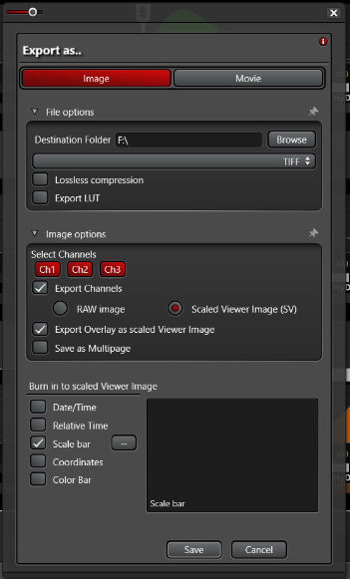

Note: Multiple images may be exported in a group by holding down either the Shift key (for all images) or the Ctrl key (for selected images). To export all images within a Project, right click on the Project name and select Export.

Note: To remove one or more channels from the overlay display, you must export each image one at a time, selecting the desired channel combination each time.

Image Series Options
A variety of image series options may be selected from the Acquisition window, under the Acquisition Mode.
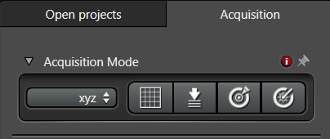
Depth (Z): XYZ, XYZt, XYZλ, XYZΛ, XYZλt,
Time (t): XYt, Xt, XYZt, XYλt, XYΛt, XYZλt
Emission Wavelength (λ): XYλ, XYZλ, XYλt, XYZλt, XYΛλ
Excitation Wavelength (Λ): XYΛ, XYZΛ, XYΛt, XYΛλ

Image Series through Depth / Z-Series:
To acquire a Z-series, select the XYZ option from the Acquisition Mode.
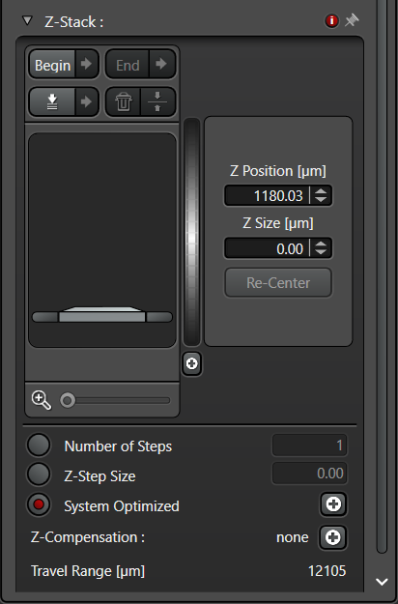
- Focus to the lower boundary of your sample and click Begin. Focus to the upper boundary of your sample and click End. Select the trash can icon to delete the selected Begin/End boundaries.
- Select the Set Focus icon to mark the current position as the primary focal position. Click on the Move to Focus to return to this position at any time.
- Once the Begin/End boundaries have been defined, select the Move to Center icon to return to the middle position within the marked boundaries. Select Re-Center to mark the current position as the new center position. This will redefine your Begin/End, but maintain the boundary range.
- The total range through the Begin/End boundary is noted by the Z Size.
- The Z-step interval will default to System Optimized, which is the Nyquist Z-step value. The Z-Step Size may also be manually entered or defined by the Number of Steps.
- Click on Start to capture the Z-Series. The Z-Series will automatically be saved in the Project.

Display options, located on the upper right side of the image, for a Z-Series include:
Max = Maximum Intensity Projection
Scissors = Orthogonal (Slice) View – XY/XZ/YZ
3D = Open in 3D Viewer
Tile = Gallery View

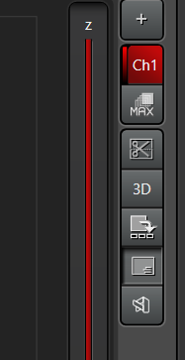

Image Series over Time / Time-Series:
To acquire a time series, select the XYt option from the Acquisition Mode.
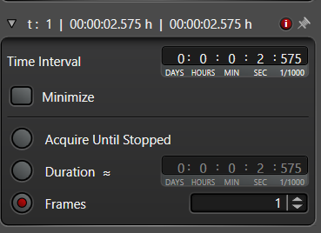
- Set the Time Interval between each image. The time interval includes the image acquisition time plus any delay time between the image capture. Select Minimize to capture the images as quickly as possible.
- The length of the time series can be selected by entering the desired Duration of the entire experiment or the desired number of Frames (images) acquired throughout the experiment. By indicating Acquire Until Stopped, the experiment will continue to acquire images until the user selects the Stop icon.
- Click on Start to capture the time series. The series will automatically be saved in the Project.

Note: Acquisition speed for a time series will be limited by how long it takes to acquire a single image (Frame). Image acquisition speed will depend on a variety of factors including:
Format – reduce the number of pixels within an image to 512x512 or lower to increase speed.
Speed – increase the speed of the scanning mirrors, which will reduce the Pixel Dwell Time, to
increase imaging speed. The default Speed is 400 Hz. Increase Speed to 600 Hz to increase the imaging speed (reduce the Pixel Dwell Time).
Bidirectional – turn on the bidirectional scan mode to increase speed.
Average/Accu – reduce Line or Frame Averaging and Line or Frame Accumulate to 1 to increase
the imaging speed.

Note: In the XYt mode, Dynamic Signal Enhancer is available, but not recommended. This option will average neighboring images over time. For example, if the DSE is set to 5, the software will average the current image with the two preceding images and the two subsequent images. The Weighted value will give a higher value, stronger weight to the current image.

Image Series over Emission Wavelength / Lambda-Series:

To acquire a lambda series, select the XYλ option from the Acquisition Mode.
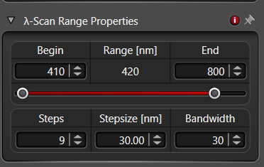
- Set the Begin and End emission wavelength values to determine the range of emissions that will be collected through the series. The minimum Begin value is 410nm and the maximum End value is 835nm.
- Set the desired Bandwidth, which is the total emission bandwidth collected per image. The minimum bandwidth value is 5um.
- Set the Stepsize, which is the increment the wavelength moves per image collected. The minimum step increment is 3um. For Nyquist sampling, it is recommended that the Stepsize be approximate ½ the Bandwidth.
- Once the Bandwidth and Stepsize have been entered, the number of Steps or images that will be collected through the series will be calculated. Alternatively, the number of desired Steps (images) can be entered, and the software will calculate the appropriate Stepsize.

For example, for an emission range covering 500nm – 650nm, with a Bandwidth of 10nm per image, then a reasonable Stepsize of 5nm or 30 Steps should be selected.

Note: Lambda After Stage – If this option is selected for a multi-position experiment, the system will first move to all stage positions, collecting the first λ, before increasing to the second λ wavelength.

Image Series over Excitation Wavelength / Excitation-Series:
To acquire an excitation series, select the XYΛ option from the Acquisition Mode.
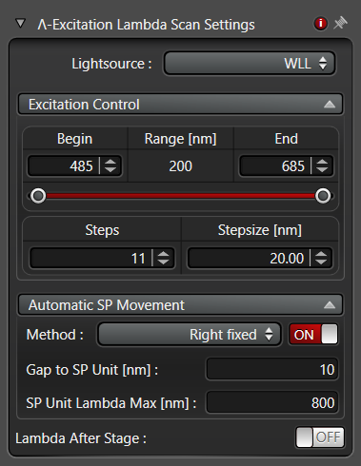
- Set the Begin and End excitation wavelength values to determine the range of excitation wavelengths that will be used through the series. The Lightsource will be limited to the continuously variable White Light Laser, with a minimum Begin value of 485nm and maximum End value of 685mm.
- Enter the Stepsize, which is the increment the laser excitation will increase between images, and the number of Steps or images to be collected. The minimum Stepsize is 1nm.

Automatic SP movement will ensure that the detector emission filter is always collecting emissions after (longer) than the moving excitation wavelength. There are two methods of controlling the Automatic SP movement:
  - Constant – In this method, the width of the band pass filter will remain constant and the distance from the laser excitation to the band pass filter will remain constant.
Gap to SP – Distance from the laser excitation to the band pass emission filter.
Bandwidth – Width of the band pass emission filter.

For example, if the excitation range was 500-600nm, Stepsize 5nm, the Gap to SP was set to 10nm, and the bandwidth was 30nm, then:
Image 1: Excitation 500nm, Emission 510-540nm
Image 2: Excitation 505nm, Emission 515-545nm
Image 3: Excitation 510nm, Emission 520-550nm

  - Right Fixed – In this method, the width of the band pass filter is not constant but will become smaller with each image. The emission band pass end point will remain fixed (Right Fixed), but the emission band pass start point will change with each image.
Gap to SP – Distance from the laser excitation to the band pass emission filter.
SP Unit λ Max – Maximum upper detection range.

For example, if the excitation range was 500-600nm, Stepsize 5nm, the Gap to SP was set to 10nm, and the SP Unit λ Max was 700nm, then:
Image 1: Excitation 500nm, Emission 510-700nm
Image 2: Excitation 505nm, Emission 515-700nm
Image 3: Excitation 510nm, Emission 520-700nm

