Leica Freeware Viewer

See link below for downloading a free LAS X offline viewer. You can open the .lif files and view z stacks by scrolling through them and show max intensity projections. You will not have 3D viewer capabilities.

https://webshare.leica-microsystems.com/latest/core/widefield/

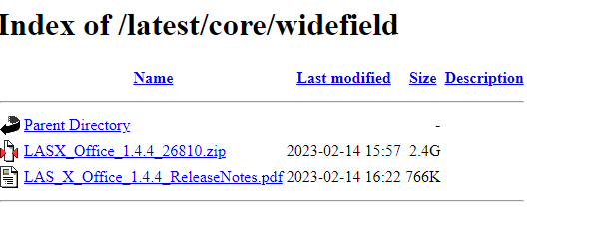

- Select and download the LASX_Office_1.4.4_26810.zip
- Extract the ZIP Files.
- You must be logged into an administrative account and close all Windows applications.
- Double click on the Setup.exe file and follow the prompts.

