Intelligent Imaging Innovations (3i) Spinning Disk Confocal System

Caution!!
*The confocal lasers are very intense. Use caution when working with these lasers.
*Never look down the barrel of the objective where the laser exits the objective lens.

Instrumentation

Yokogawa CSU-W1 T1 Spinning Disk with 50um pinhole disk
17mm x 16mm FOV

Prime 95B Back Illuminated sCMOS camera
1200x1200 pixels, 11x11um square pixels, 18.7mm FOV
95% Quantum Efficiency
Speed 0 = 12 bit/82 fps or 12msec/image - Gain only works in 12-bit mode
Speed 1 = 16-bit/41 fps or 24msec/image
Note: Binning on a CMOS camera will make the image brighter but does not significantly increase imaging speed.
CMOS – 4-pixel binning – 4 readouts
CCD – 4-pixel binning – 1 readout
To Crop – use Marquee tool to mark area and then select camera to update number of pixels
To center an object within the field of view of the camera, double click left on the object within the image.

Lasers: 445nm – 100mW
488nm – 150mW
514nm – 150mW
561nm – 150mW
637nm – 140mW

Multi-Pass Excitation Dichroic/Single Emitter Laser Position Emission Filter Wheel
c445 440/514/561 2 – 445nm 4 - 482/35 = 464.5-499.5nm BP
c488 405/488/561/640 3 – 488nm 5 - 525/30 = 510.0-540.0nm BP
c515 440/514/561 4 – 514nm 6 - 542/27 = 528.5-555.5nm BP
c561 405/488/561/640 5 – 561nm 7 - 617/73 = 580.5-653.5nm BP
c640 405/488/561/640 6 – 637nm 8 - 692/40 = 672.0-712.0nm BP

Quad-Pass Ex Dichroic/Quad BP Emitter Laser Position Emission Filter Wheel
q488 405/488/561/640 3 – 488nm 1 – 440/521/607/700
q561 405/488/561/640 5 – 561nm 1 – 440/521/607/700
q640 405/488/561/640 6 – 637nm 1 – 440/521/607/700

Triple-Pass Ex Dichroic/Tri BP Emitter Laser Position Emission Filter Wheel
t445 440/514/561 2 – 445nm 2 – 475/543/702
t515 440/514/561 4 – 514nm 2 – 475/543/702
t640 440/514/561 5 – 561nm 2 – 475/543/702

Instrument Set-up
- Turn all components of the 3I Spinning Disk hardware “ON”.
- Open the 3I Slidebook 2022 software.
- Click on the Focus icon. The Camera window and Focus window will appear.
- Click on the Capture icon. The Capture window will appear.
- If the Focus and Capture icons are not available, be sure that a SlideBook is open. To create a new SlideBook, select File/New SlideBook.

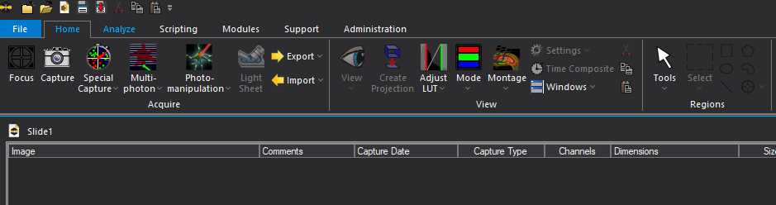

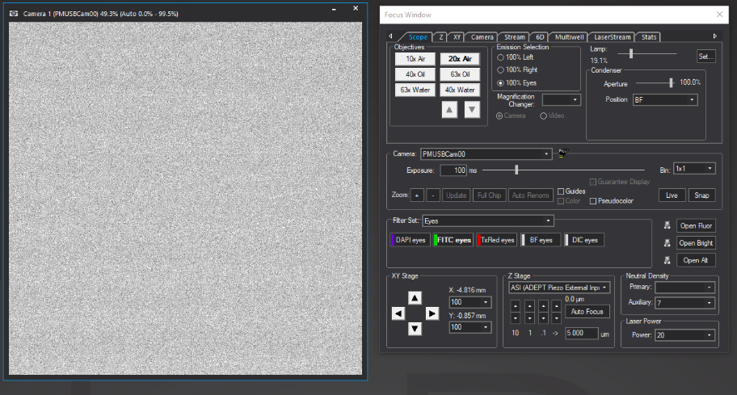

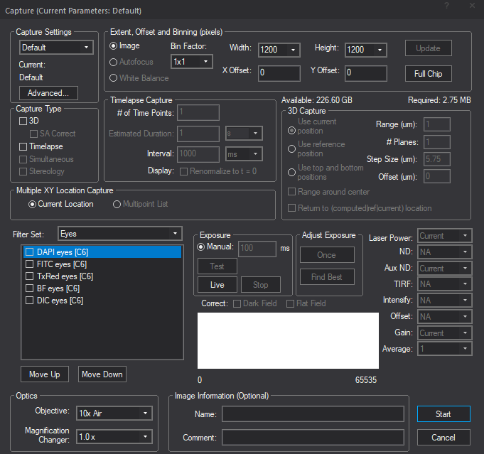

Microscope Control
- The Zeiss automated microscope can be controlled through the Focus widow, the microscope itself, and the microscope handset controller.

- The Zeiss Objectives that are available include:
10x Air NA 0.3 Working Distance = 5.2mm
20x Air NA 0.8 Working Distance = 550um
40x Oil NA 1.3 Working Distance = 201um
63x Oil NA 1.4 Working Distance = 190um
40x Water NA 1.2 Working Distance = 280um
63x Water NA 1.2 Working Distance = 280um

- Focus Window / Emission Selection
100% Left = Spinning Disk/Camera
100% Right = not an option
100% Eyes = Ocular/Eye Port View
Lamp = Halogen Lamp, % = lamp intensity
Condenser Aperture = Contrast setting for Brightfield or DIC images
Condenser Position = BF (Brightfield)
DIC II, for 10x and 20x objectives
DIC III, for 40x oil, 63x oil, 40x water, and 63x water objectives
Phase – no phase objectives are available
Note: For DIC imaging, you must also insert:
Polarizer (located above the condenser)
Analyzer (position 5 on the filter wheel)
Matching DIC prism inserted below the objective

- Focus Window / Filter Set
Eyes – Ocular view of conventional fluorescence (blue, green, or red) or transmitted
light (BF or DIC).
Wide Field – Camera recording of conventional fluorescence (blue, green, or red) or
transmitted light (BF or DIC).
CSU-Single Band – Spinning Disk, Single Laser Excitation/Single Band Pass Emission Filter
MultiBand Em – Spinning Disk, Single Laser Excitation/Multi Band Pass Emission Filter

Open Fluor – Mercury Arc Lamp Shutter
Open Bright – Halogen Lamp Shutter
Open Alt – Laser Shutter

- Focus Window / XY Stage
Automated control of XY Stage, in 10um, 1um, 0.1um or FOV (Field of View) increments.

- Focus Window / Z Stage
Automated control of Piezo Z-focus, in 10um, 1um, 01.um or user-defined increments.
Please note that the Piezo Z-focus has a 300um total focus limit. It is recommended that the microscope coarse/fine focus knob be used to set the initial focus of the sample.

- Focus Window / Neutral Density
Not functional on our system.

- Focus Window / Laser Power
Controls intensity of the laser power from 1-100% of total power.

Camera Control
- Focus Window / Camera
PMUSBCAM00 = Prime 95B Back Illuminated sCMOS camera

Exposure – Increase exposure time to increase the brightness of your image.
Exposure time should be greater than 10msec to avoid lines within the image.
Bin – 1x1 and 2x2 are available. 4x4 and 8x8 binning are not available.
2x2 binning will increase the brightness of your image. However, the increased
pixel size will result in a decrease in the image resolution.
Update – Use the Marquee tool to draw a region of interest (ROI) and then select
Update to crop the image. The image will have the same pixel size, but fewer
pixels. Select Full Chip to return to the full field of view.
Guide – Useful for centering your field of view.
To center an object within the field of view, double click left on the object.
Pseudocolor – Useful for distinguishing intensity within your image.
Blues/greens represent low intensity. Yellows/reds represent high intensity.

Live – turns the camera on
Stop – turns the camera off
Snap – takes a snapshot of the current image

- Focus Window / Camera tab
Scale Image = Pixel Histogram = Look Up Table = LUT
Manual – Manually set your Low value and High value for your LUT.
The Manual option is recommended.
Auto – Computer automatically and continuously rescales your image for
the current dynamic range.
0-99% - Leave this option selected.
Range – Number of pixels about center for auto scale
Fan - Leave this option selected.
Speed – 0 – 12-bit display, 0-4095 intensity values
1 – 16-bit display, 0-65,535 intensity values
Gain – 1x, 2x, 3x – only available in Speed 0, 12-bit display mode.

- Capture window / Extent, Offset, Binning (pixels)
Bin Factor – 1x1 and 2x2 are available. 4x4 and 8x8 binning are not available.
Width/Height/X Offset/Y Offset – Use to crop the current field of view.
Options include 256x256, 512x512, 1024x1024, 1200x1200
To center an object within the field of view, double click left on the object.
Alternatively, use the Marquee tool to draw a region of interest (ROI) and then select
Update to crop the image. The image will have the same pixel size, but fewer
pixels. Select Full Chip to return to the full field of view.

Setting 3D Focus Boundaries
- Find the approximate center focal plane of your sample using the manual microscope coarse/fine focus knob.

- Use the Piezo Z-drive up/down arrows (Focus Window / Z Stage) to find the lower boundary and the upper boundary of your sample. It is recommended that the Scale Image be set to Manual before locating your sample 3D boundaries. Once the lower boundary is located, click the Bottom button within the Focus/Z tab. Once the upper boundary is located, click the Upper button within the Focus/Z tab.

Enter the Step Size and the software will automatically calculate the Number of Planes (optical sections) and the Total Travel (total thickness).

Click on Optimal to set the Step Size to Nyquist.

- To capture an XY-Z series, from the Capture window / Capture Type, select 3D.

- Within the 3D Capture window, select:
Use Current Position – The first image in the series will be the current position. The series will then focus up (go deeper into the sample) using the specified Range, # Planes, and Step Size.

Use Reference Position – The first image in the series will be at the designated Reference Position, which is set in the Focus Window / Z tab. The series will then focus up (go deeper into the sample) using the specified Range, # Planes, and Step Size.

Use Top and Bottom Position – The XY-Z series will use the top and bottom boundaries which were set in the Focus Window / Z tab, using the specified # Planes, and Step Size.

Range Around Current – The first image in the series will focus down by 1/2 the specified Range. The series will then focus up (go deeper into the sample) through the specified Range using the specified # Planes and Step Size.

Setting Multiple XY Locations or Montage Boundaries
- Use the Focus Window / XY tab to set multiple XY Locations and Montage boundaries.
- Once multiple XY locations have been identified, the Multipoint List option will be available in the Capture / Multiple XY Location Capture window.
- For a montage, once the montage boundaries have been identified, the Montage option will be available in the Capture / Multiple XY Location Capture window.

6D Imaging
- Within the Focus Window tab, optimize the Exposure and Laser Power for each dye.
- Go to the Capture tab and set the image parameters for the first phase of the experiment.
Remember to set:
-the Filter Set
-the Exposure
-the Laser Power (“Current” is not recommended)
-Full Chip or ROI (Width and Height)
Draw ROI box on image and select Update to update the camera dimensions.
-Timelapse: enter the # of Time Points and Interval (set to 0 for no delay)
-3D / 3D Capture: Set Z focus boundaries as described in Part V.
- To save these image settings for the first phase of the experiment, go to Capture / Capture Settings, select Save As and enter a Description that will be the filename for the first phase of the experiment.
- Repeat steps 2/3 for each phase of the experiment.
- From the Focus Window / XY tab, select Set Point to identify the X, Y, Z position for the first phase of the experiment. Remember to use the computer-controlled piezo Z Stage to determine the focal position. Do not use the microscope coarse/fine focus.
- Repeat step 5 for each phase of the experiment. You should have an XYZ location that can be assigned to each experiment phase.
Note: If you have 3 phases to your experiment, you must have 3 XYZ locations, even if it is exactly the same XYZ location. To copy a location, double click on the position to be copied (not single click) and then select Set Point.
- From the Focus Window / 6D tab, all of the designated locations (Set Points) from steps 5/6 should be listed. Again, there should be a location for each experiment phase.
- Next, each location will be assigned to the image parameters/experiment phase that was saved in steps 2/3. To assign the saved image parameters for each experiment phase to the saved XYZ locations, click on the XYZ location and then from Capture script select the name of the associated experiment phase (determined in steps 2/3). For a delay between phases, enter the desired delay time in the Pause After Script.
- Repeat step 8 for each phase of the experiment.
- To begin the experiment, click on the 6D icon. Enter a desired filename under Name and select Start.

Saving Data
- Raw Data: Select File / Save or Save As – Saves raw data in SlideBook in .sld format.
To copy a single image within a SlideBook to a second SlideBook, click on the image filename and select control/copy. Then, click on the new SlideBook and select control/paste. You must use the keyboard control (Cntrl/V) for the paste option. The software selection (right click/Paste) does not work.

- Quantitative Data Export: Select Export icon (yellow arrow) 16-bit TIFF (OME) or MATLAB

- Qualitative Data Export: Select Export icon (yellow arrow)
RGB TIFF (24-bit) – saves current view exactly as displayed as 24-bit color TIF
TIFF Series – exports entire series, each image in the series as its own color TIF
All Default Views as TIFF – exports all files within the SlideBook, each image in each file/series as its own color TIF
Export All Channels as 8-bit TIFFS – exports each channel of current view as its own grey-scale TIFF

- To re-use previous settings, Right Click on the image filename within the SlideBook and select Recapture Experiment.

Image Speed Comparisons

For comparison, a two-color image was collected under different camera conditions.
Total exposure time for the two-color image was 120msec (green 20msec, red 100msec).

Pixel Density | Emission Dichroic | Binning | Speed  (Bit Depth) | Gain | Time per image | Pixel Size
1200x1200 | Single | 1x1 | 0 | 1 | 654 msec | 0.529 um
1200x1200 | Single | 1x1 | 0 | 2 | 656 msec | 0.529 um
1200x1200 | Single | 1x1 | 0 | 3 | 655 msec | 0.529 um
1200x1200 | Single | 1x1 | 1 | 1 | 703 msec | 0.529 um
1200x1200 | Single | 2x2 | 0 | 1 | 644 msec | 1.058 um
1024x1024 | Single | 1x1 | 0 | 1 | 646 msec | 0.529 um
512x512 | Single | 1x1 | 0 | 1 | 610 msec | 0.529 um
256x256 | Single | 1x1 | 0 | 1 | 593 msec | 0.529 um
256x256 | Single | 2x2 | 0 | 1 | 593 msec | 1.058 um
Crop 92x92 | Single | 1x1 | 0 | 1 | 593 msec | 0.529 um
1200x1200 | Quad | 1x1 | 0 | 1 | 322 msec | 0.529 um
512x512 | Quad | 1x1 | 0 | 1 | 278 msec | 0.529 um
512x512 | Quad | 2x2 | 0 | 1 | 275 msec | 1.058 um
Crop 92x92 | Quad | 1x1 | 0 | 1 | 256 msec | 0.529 um

