**Keyence VHX-6000**

1. **Hardware**

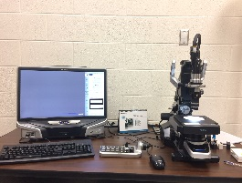

**Monitor/Computer = Controller XY Stage/Lens/Camera = Microscope**

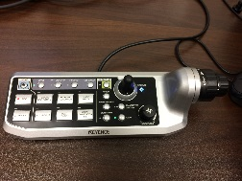

**Handset = Console**

1. **Turn the system “On” by pressing the O/I button located on the lower, right of the Controller.** The software/hardware will take about 1 minute to initialize.

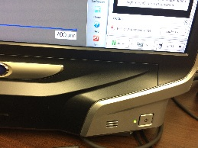

1. **Insert your USB drive into one of the USB ports located on the lower, left of the Controller.**

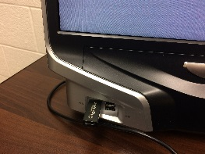

**Camera: VHX-6020**

**Lenses: VH-Z20R** Zoom Magnification from 20x – 200x (25mm WD)

**VH-Z500R** Zoom Magnification from 500x – 5000x (4mm WD)

**Lens Caps for the VH-Z20R:**

Black cap with opaque ring – standard for VH-Z20R

This is a diffuser that helps spread the light uniformly across the sample and will help reduce glare from the sample.

Silver cap with clear ring – used with VH-Z20R for dark samples

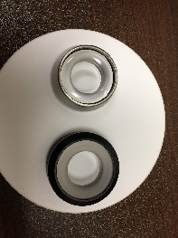

**Stage Plates:** Reversible Black/White Plate

Transparent Plate for transmitted light applications

1. **Select the appropriate lens, lens cap and stage plate for your application.**

**To remove the camera from a zoom lens:**

Remove the camera from the lens by pressing down on the **black tab** located on the middle, right of the camera (A). Simultaneously, turn the camera to the right until the **two white dots** align (B). When the dots are aligned, pull up to remove the camera from the lens. The camera may be temporarily stored on the camera holder located on the top, back of the microscope base (C).

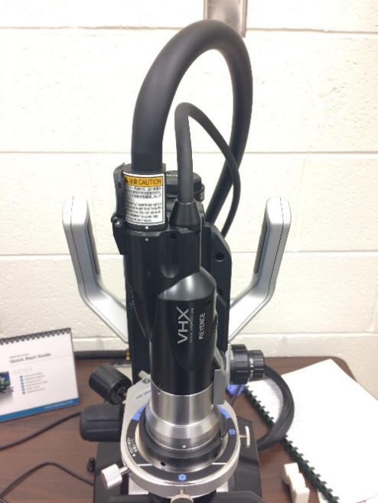 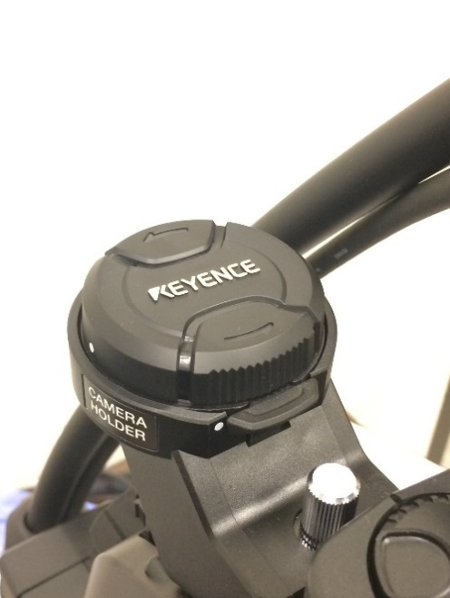

**A**

**B**

**B**

**A**

**C**

**To remove a zoom lens from the microscope base:**

Loosen the black **Joint Mounting Knob** and slide the lens up and off the silver rod attached to the microscope base.

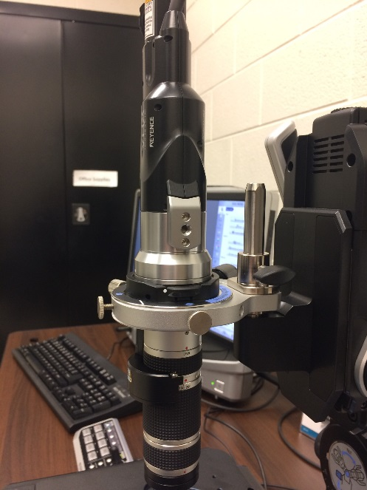

**To attach a zoom lens to the microscope base:**

Slide the new lens down onto the silver rod and tighten the Joint Mounting Knob.

**To reattach the camera to a zoom lens:**

Reattach the camera to the lens by aligning the two white dots, inserting the camera into the lens and then turning the camera to the left until the two components click, indicating that the camera is locked into position.

**To install the VH-Z20R lens**:

Follow the instructions listed above. Note that there are two adjustable apertures on the VH-Z20R lens, in addition to the adjustable zoom lens magnifications (20x-200x). The top aperture should always be open (red dot aligned with Open). The aperture at the very bottom of the lens should have the black line aligned with the red dot.

**To remove the VH-Z20R lens**:

Follow the instructions listed above and remember to install the camera mount cover on top of the lens before placing the lens in the black, plastic protective box.

**To install the VH-Z500R lens:**

1. Remove the VH-Z20R lens as directed above.
2. Slide the VH-Z500R lens down onto the silver rod and tighten the Joint Mounting Knob.
3. Note there are three covers for the VH-Z500R lens that must be removed.

Camera Mount Cover

Light Guide Plug

Zoom Lens Cover

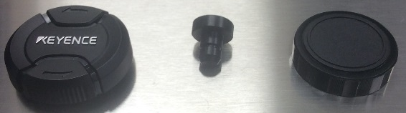

1. Remove the Camera Mount Cover and attach the camera as described above.
2. Remove the Light Guide Plug from the VH-Z500R lens. Turn the system’s light illumination “off” but clicking the **Light** button on the Console. Remove the light guide from the camera mount by pulling straight up on the base of the light guide. Insert the light guide into light guide mount on the lower left of the VH-Z500R lens. The flat side of the light guide should face the zoom lens and the white dot on the light guide should face forward. Use the locking screw on the left of the light guide mount to lock the light guide into place. Remember to turn the system’s light illumination on again by clicking the **Light** button on the Console.
3. The light guide aperture on the VH-Z500R lens should be set to **NORMAL** (not Edge).

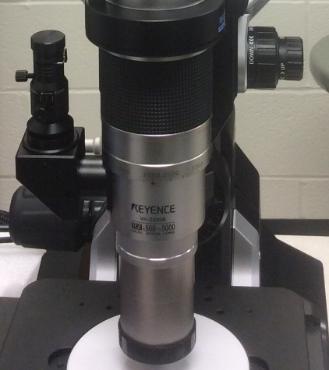 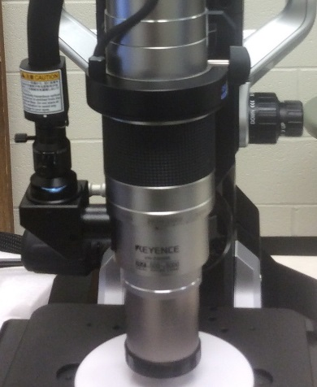

**Zoom Lens Cover**

**Light Guide Aperture**

**Light Guide Mount**

**Light Guide Set Screw**

1. Remove the Zoom Lens Cover from the bottom of the lens. The lens is now ready for use.

**To remove the VH-Z500R lens:**

1. Replace the Zoom Lens Cover on the bottom lens.
2. Turn the system’s light “off” by clicking on the **Light** button on the Console. Loosen the light guide mount set screw and remove the light guide. Reinsert the light guide into the camera’s light guide mount. To insert the light guide, lift the small cover of the camera’s light guide mount (top, rear of camera), match the white dot on the light guide with the white dot on the camera’s light guide mount and insert the light guide. The light guide should fit securely, although there is no locking screw for this mount. Remember to turn the system’s light “on” by clicking on the **Light** button on the Console and to replace the Light Guide Plug on the VH-Z500R lens.
3. Remove the camera from the VH-Z500R lens and replace the Camera Mount Cover on the lens.
4. Loosen the black Joint Mounting Knob, slide the lens up and off the silver rod, and place the lens back into the black, plastic protective case.
5. **Place the sample onto the appropriate stage plate.**

**Note: Sample orientation will be from the right side of the stage.**

**A**

**A**

**Monitor View**

**Microscope Position**

1. **Focus on the sample.**

There are several options for optimizing the focus of the sample.

1. **Camera mount focus:**

Use the fine/coarse knobs attached to the left side of the camera mount itself to adjust the camera mount position.

**For most samples, coarse adjustment of the camera mount should position the top of the camera mount just below the attachment screws.**

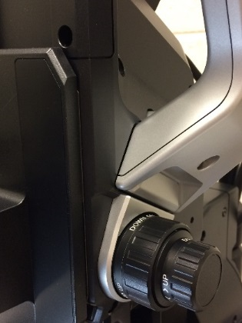 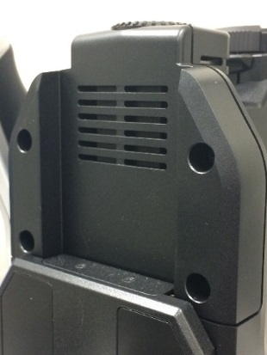

1. **XY stage focus**:

The large, black knobs to the right/left of the microscope base will move the XY **stage** up and down.

Please note:

-If you move the stage down (turn the focus towards you), then the stage will move away from the camera and the camera will focus closer to the top surface of the sample.

-If you move the stage up (turn the focus away from you), then the stage will move closer to the camera and the camera will focus deeper into the sample, closer to the stage plate.

**The surface of the sample should be approximately 25mm from the bottom of the VH-Z20R lens and approximately 4mm from the bottom of the VH-Z500R lens.**

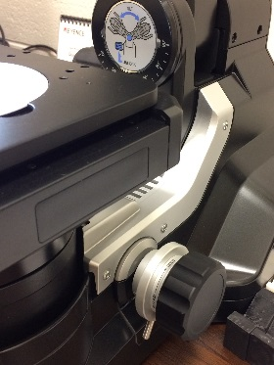

1. **Focus of the camera mount using the console and/or the mouse**:

The fine/coarse knobs attached to the right side of the Console will move the camera position up and down for focusing.

The mouse scroll wheel can also be used to move the camera position up and down. For fine focus, scroll the mouse wheel to focus up and down. For coarse focus, push down on the mouse wheel to coarsely focus up and down.

These controls move the **camera** position up and down.

Please note:

-If you move the camera down (turn the focus towards you), then the camera will move closer to the sample and the camera will focus deeper into the sample, closer to the stage plate.

-If you move the camera up (turn the focus away from you), then the camera will move away from the sample and the camera will focus closer to the top surface of the sample.

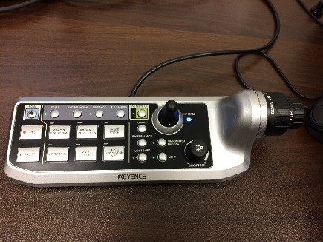

1. **Auto Focus**:

When the focus knob on the Console or the mouse wheel is adjusted, the **Focus Adjustment** dialog box will appear on the computer screen a small green box will appear on your image.

-The Auto Focus option will focus on the details located within the green box. The size of the green box on the image can be adjusted (S, M, L, XL) and the position of the green box can be adjusted using the mouse.

**To AutoFocus your sample, double-click left on the structure of interest or press the AutoFocus button on the Console.**

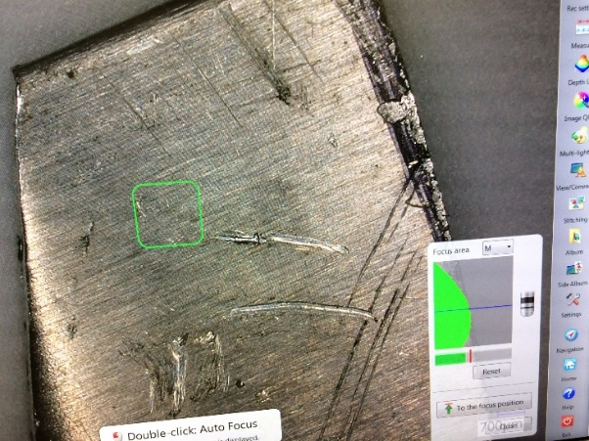

1. **Move the sample / XY stage position.**

*Note: If the camera will be tilted for off-angle imaging,* ***first*** *make sure the XY Stage position is centered by pressing the* ***Origin*** *button on the Console and* ***then*** *place your sample within the center of the field of view on the XY Stage. The Origin button is located on the Console below the Live DepthUp and to the left of the joystick.*

There are several options for adjusting the XY Stage position.

1. Adjust the XY Stage joystick on the Console.

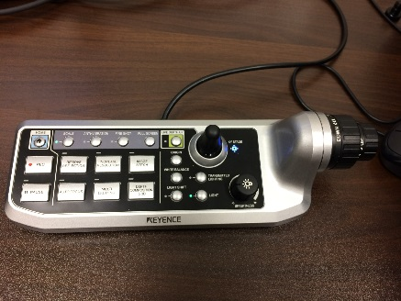

1. Double-click left on a feature within the image to move the object to the center of the field of view.
2. Left-click on the image and drag to move the stage.
3. Navigation View dialog box.

From the Navigation View dialog box, select **Register** to create a navigational image within the dialog box. Left-click on the navigational image to move the field of view. If the Navigation View dialog box is not displayed, select the Navigation option (blue icon with the red arrow).

*Hint: Select the lowest zoom on the camera lens to acquire a large overall field of view for the Navigation image. As you increase camera zoom, you can still navigate on the low-zoom image.*

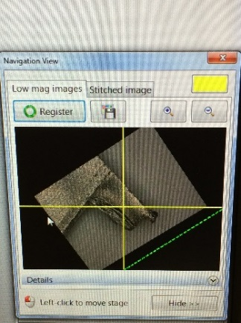

1. **Rotate the stage to adjust the orientation of the sample.**

Unlock the stage by turning the silver locking screw located on the lower left of the XY stage. Once the stage unlocked, the orientation of the stage can be adjusted by grasping the blue handle on the front, right of the stage and pushing to the left or right.

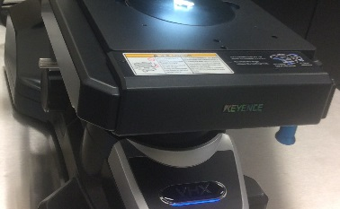

**Blue Handle**

**Silver Locking Screw**

1. **Tilt the camera to visualize the sample at an angle.**

The controls for releasing the camera tilt position are located on the left, rear of the microscope base.

1. Unlock the camera tilt by moving the top lever to the left so it is in a vertical position.
2. Release the Tilt Lock knob so that the camera tilt can be adjusted.
3. Using the handles located on the side of the microscope base, adjust the tilt of the camera. The camera tilt is normally limited to a 60o tilt angle.
4. Once the camera tilt is optimized, lock the camera position using the Tilt Lock knob.
5. For a tilt angle greater than 60o, pull the middle, silver knob out while moving the camera position past the 60o position. The tilt limit is 90o.

**Take great care when moving the tilt position that the Zoom Lens does not hit the sample or the stage!**

1. To return to a 0o tilt, release the Tilt Lock knob, return the camera tilt position to a vertical position, return the top lever to a locking position by moving the knob to the right in a horizontal position. You should feel the lock knob engage and the camera position should not move.

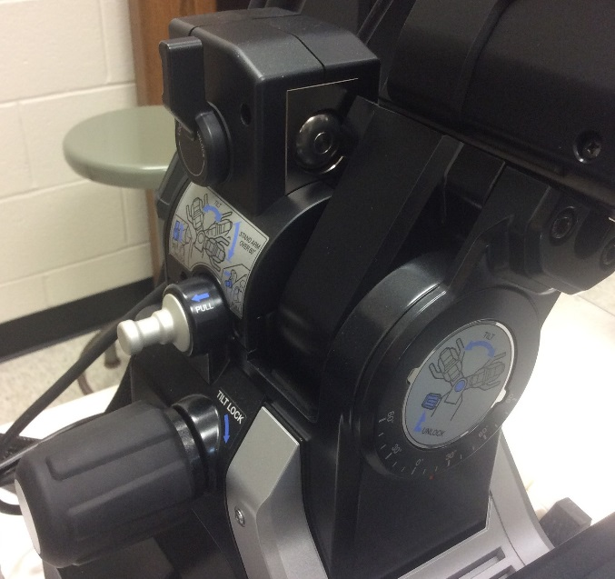

**Tilt Angle Indicator**

**Tilt Lock knob.**

**Turn clockwise to Lock and counter clockwise to Release.**

**Pull silver knob out for tilt angles greater than 90-degrees.**

**Unlock camera tilt. Locking knob should be verticle position.**

1. **Monitor and Record hardware settings.**

The bottom, right of the software monitor will track and display many of the hardware settings. These paraments will be saved with your image, These parameters include:

Lens Name (Z20)

Zoom Magnification (X50)

Tilt Angle (O Deg Locked)

Stage Rotation (0 Deg)

1. **Console**

Options include:

**Home** – returns to default computer settings.

**Rec** – takes a snapshot of the current image.

**Pause** – freezes camera and stage options.

**Scale** – turns display of the scale bar on/off.

**Anti-Vibration - ?**

**Fine Shot** – corrects for lens distortion.

The correction is only applied to the captured (Rec) image, not to the Live image.

**Full Screen** – full screen image display.

**Live DepthUp** – continuously updates DepthUp image in real-time.

**Origin** – moves the XY Stage to the center of the field of view.

**White Balance** – color correction for the camera.

**Transmitted Lighting** – turns lower light illumination on for transmitted light.

**Light Shift – changes illumination mode. ??**

**Light** – turns light illumination on/off.

**Remove Reflection** – Image Quality option for Glare and Ring Removal options.

**Increase Resolution** – Image Quality option for HDR options.

**Image Stitch** – Stitching option for large area scan.

**Auto Focus** – automatically detects and adjusts sample focus.

**Multi Lighting** – Multi Lighting option to illuminate and collect at 4 illumination angles.

**Depth Composition & 3D** – DepthUp option.

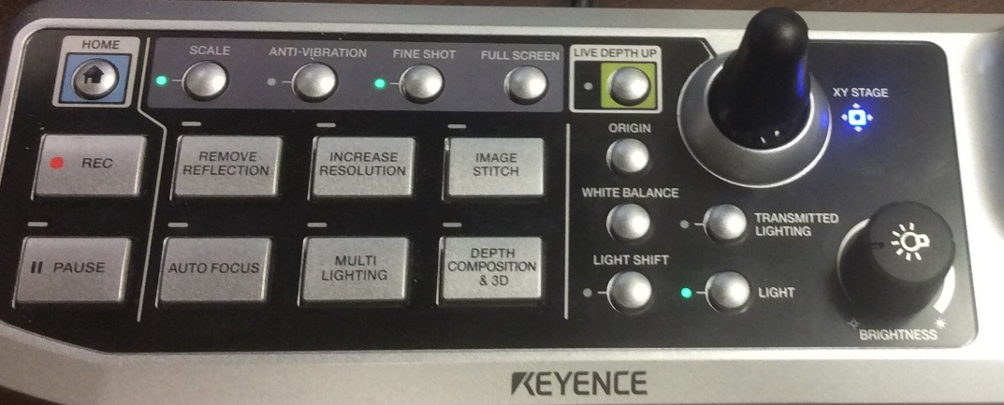

1. **Software**
2. Add a Scale:

Press the **Scale** button on the Console or select **Measure/Scale/Scale Width** from the software.

1. **Depth Up** (Extended Focus Image or Through Focus Image)

Press the **Depth Up** button on the Console (once) or select the **Depth Up** software option for the **Depth Up / Live Comp Mode**.

Press the Depth Up button twice on the Console to select “Live Depth Up”, automatically performed each time the stage is moved. A green light will be displayed when Live Depth Up is selected.

LiveDepth Composition Mode / Auto Comp Mode

Move to the bottom of the structure (move camera down or XY Stage up).

Camera will always move up/away from the sample, focusing towards the top surface of the sample. So, always start at the bottom, deeper into the sample.

3D Display

Quick Composition & 3D – same as Depth Up

If select Show Depth Up = Depth Up Ext Depth

Fine Depth Composition – manually set upper & lower limit and step size

Z stage control = manually set upper and lower boundaries, select 2 areas & auto measure height difference

Manual 3D composition same as Quick Composition

1. Capture an Image: Click the Pause button on the Console or within the software.

The Pause button will be grey during live recording. The Pause button will be green for a fixed snapshot image.

1. Save an Image: Click the Rec button on the Console or within the software.

AutoRecord/Rec Settings

Rec Size – Save at current size: 1600x1200

Auto Record – USB drive, Tif/Jpeg/filename, turn AutoRec on

1. Open previously saved image:

Select either Album (whole screen) or Side Album (retains image on the left and file options on the right) from software menu.

1. Compare multiple live and/or stored images:

Select View/Comment from the software menu. Select desired split screen option. A red frame will border the active image. To add an image, click on a different section of the split screen and then change the imaging field of view or parameter or open a stored image using the side Album option.

Select the wide-field option to view the Widefield dialog box. Permits zooming of single selected field of view or to sync the zoom for all fields of view.

1. Load Previous settings:

Select Side Album and select Reproduce Rec Settings. You can Reproduce Rec Settings (which loads previous settings) or Show Settings to view the setting options.

1. To end imaging session: Select Exit menu option

Select Shutdown

XY Stage will move to origin – OK

1. Lighting options:

Light Shift: Full Ring versus Partial Ring – surface detail easier to see.

Multi lighting options

Changing the lens and lens cap

Adjust color balance = Press White Balance button on the Console

Control Brightness = Adjust the Brightness dial (lamp intensity) on the Console